function convertItemsToGWServicePayload(invoiceItems) {

var i, invoiceItem, gwInvoiceItems = [], gwInvoiceItem;

for (i = 0; i < invoiceItems.length; i++) {

invoiceItem = invoiceItems[i];

gwInvoiceItem = {

ZimageFingerprint: invoiceItem.invoiceGUID,

Zinvno: invoiceItem.invoiceID,

Zitemindex: invoiceItem.invoiceItemIndex,

ZdocType : invoiceItem.documentType,

ZdocDate : invoiceItem.documentDate,

Zinvdate : invoiceItem.invoiceDate,

// ZpostingDate: "",

ZinvoicingParty : invoiceItem.invoicingParty,

ZcompanyCode : invoiceItem.companyCode,

Zcurrency : invoiceItem.paymentCurrency,

// "ZinvType": "",

// "ZheaderText": "",

ZvendorNo : invoiceItem.supplierNumber,

// "ZpaymentMethod": "",

// "ZpaymentBlock": "",

// "ZpartnerBank": "",

// "ZhouseBank": "",

// "ZhouseBankAccid": "",

// "ZpaymentMethodSupp": "",

// "ZautocalTax": "",

// "ZtotalTaxAmt": "",

ZtaxJursidiction: invoiceItem.taxJurisdiction,

// "ZbaselineDate": "",

// "ZdueOn": "",

// "ZvatAmount": "",

// "ZvatAmount1": "",

// "ZvatAmount2": "",

// "ZvatAmount3": "",

// "ZvatAmount4": "",

// "ZvatRate": "",

// "ZvatRate1": "",

// "ZvatRate2": "",

// "ZvatRate3": "",

// "ZvatRate4": "",

ZautocalTax : invoiceItem.autoCalculateTaxIndicator,

Zitemtax : invoiceItem.itemTax,

ZsupplierName : invoiceItem.supplierName,

ZinvFreightAmt : invoiceItem.invoiceFreightAmount,

ZsupplierName2 : invoiceItem.supplierName2,

Zreminame : invoiceItem.remitName,

Zremittoaddr1 : invoiceItem.remitToAddress1,

Zremittoaddr2 : invoiceItem.remitToAddress2,

Zremittostreet : invoiceItem.remitToStreet,

Zremittopin : invoiceItem.remitToPin,

Zremittovat : invoiceItem.remitToVAT,

Zbilltocompany : invoiceItem.billToCompany,

Zbilltoaddr1 : invoiceItem.billToAddress1,

Zbilltoaddr2 : invoiceItem.billToAddress2,

Zbilltocountry : invoiceItem.billToCountry,

ZsupplierStreet : invoiceItem.supplierStreet,

ZsupplierPoBoxZip : invoiceItem.supplierPOBoxZip,

Zbilltoemail : invoiceItem.billToEmail,

ZpaymentTerm : invoiceItem.paymentTerms,

ZglAccount : invoiceItem.glAccount,

ZglDescription : invoiceItem.glDescription,

ZcostCenter : invoiceItem.costCenter,

Zwbs : invoiceItem.wbsElement,

ZinternalOrder : invoiceItem.internalOrder,

ZnetAmount: invoiceItem.netAmount,

// "Zday1": "",

// "Zday2": "",

// "Zday3": "",

// "Zdisc1": "",

// "Zdisc2": "",

// "ZexchangeRate": "",

// "Zwht": "",

// "ZunplannedDeliveryCost": "",

// "ZinstKey": "",

ZbankAcc: invoiceItem.bankAccount,

ZbankName: invoiceItem.bankName,

ZbankNo: invoiceItem.bankNumber,

ZbankPartnerType:invoiceItem.bankPartnerType,

// "ZvatId": "",

// "ZvatId1": "",

// "ZvatId2": "",

// "ZvatId3": "",

// "ZvatId4": "",

// "ZreqEmil": "",

// "ZinvFreightAmt": "",

// "ZinvHandlingCharges": "",

// "ZalternatePayee": "",

ZdocItmInInvDoc : invoiceItem.documentItemInInvoice,

ZpoNo : invoiceItem.purchaseOrder,

ZitemnoPurchingDoc : invoiceItem.itemPurchaseOrder,

ZpoUnitOfMeasure : invoiceItem.uomPurchaseOrder,

ZamtDocCurr : invoiceItem.amountDocumentCurrency,

ZitemDesc : invoiceItem.itemDescription,

ZunitPrice : invoiceItem.unitPrice,

ZdeliveryNote : invoiceItem.deliveryNoteNumber,

// "ZitemTaxAmt": "",

// "ZitemTaxRate": "",

ZmaterialNo : invoiceItem.materialNumber,

// "ZtaxCode": "",

// "ZaccAssignBasedInv": "",

ZdirectPostGl : invoiceItem.directPostingGL,

ZdirectPostMaterial : invoiceItem.directPostingMaterial,

// "Zstatus": "",

// "ZtimeStamp": "",

// "ZlastUser": "",

// "ZcurrentUser": "",

// "ZlastUpdatedTimeStamp": "",

// "ZlastRole": "",

// "ZinvoiceCategory": "",

// "Zshiptoaddress1": "",

// "Zshiptoaddress2": "",

// "Zbilltocompany": "",

// "Zbilltoname": "",

// "Zbilltophone": "",

// "Zbilltoaddr1": "",

// "Zbilltoaddr2": "",

// "Zbilltocountry": "",

// "Zbilltovat": "",

// "Zbilltoemail": "",

// "Zreminame": "",

// "Zremittoaddr1": "",

// "Zremittoaddr2": "",

// "Zremittopin": "",

// "Zremittostreet": "",

// "Zremittovat": "",

// "ZremitToEmail": "",

// "ZremitToPhone": "1234567890",

// "ZsupplierNumber": "",

// "ZsupplierName": "",

// "ZsupplierName2": "",

// "ZsupplierPoBox": "",

// "ZsupplierPoBoxZip": "",

// "ZsupplierStreet": "",

// "ZsupplierState": "",

// "ZsupplierZip": "",

// "ZnetAmount": "",

// "Zterms": "",

// "Zrate": "",

// "Ziban": "",

// "Zswift": "",

ZgrossAmount : invoiceItem.grossAmount,

ZtotalTaxAmt : invoiceItem.totalTaxAmount,

Zitemno : invoiceItem.itemNumber,

Zitemprice : invoiceItem.itemPrice,

Zitemqty : invoiceItem.itemQuantity,

Zitemunit : invoiceItem.itemUnit,

Zitemqtyship : invoiceItem.itemQuantityShipped,

Ztotalamount : invoiceItem.totalAmount,

Zpgidate : invoiceItem.pgiDate,

ZitemCode : invoiceItem.itemCode,

ZdeliveryNoteNumber : invoiceItem.deliveryNoteNumber

// "ZcurrentRole": "",

// "ZcompanyCodeLineItm": "",

// "ZglAccount": "",

// "ZglDescription": "",

// "ZcostCenter": "",

// "ZcostCenterDescription": "",

// "Zwbs": "",

// "ZwbsDescription": "",

// "ZinternalOrder": "",

// "ZinternalOrderDescription": "",

// "Zasset": "",

// "ZassetDescription": "",

// "Zfilename": "",

// "ZpostedInvoice": ""

};

gwInvoiceItems.push(gwInvoiceItem);

}

return gwInvoiceItems;

}

function generateGWInvoiceValidationPayload(invoiceItems) {

var gwInvoiceItems = convertItemsToGWServicePayload(invoiceItems);

var requestPayload = {

d : {

ZimageFingerprint : "",

Finger_to_Processed : gwInvoiceItems,

Finger_to_Exceptions : []

}

};

return requestPayload;

}

function validateInvoice(invoiceItems) {

try {

var httpClient = new $.net.http.Client();

var gwInvoiceValidation = $.net.http.readDestination(

"coms.deloitte.apps.invoiceprocessor.services.saveInvoice",

"GW_InvoiceValidation");

var request = new $.net.http.Request($.net.http.POST, "");

request.headers.set("X-Requested-With", "X");

request.headers.set("Content-Type", "application/json");

request.headers.set("Accept", "application/json");

request.headers.set("SAP-Connectivity-SCC-Location_ID", "SCPINVST");

request.headers.set("X-CSRF-Token", "CSRF");

var requestPayload = generateGWInvoiceValidationPayload(invoiceItems);

request.setBody(JSON.stringify(requestPayload));

httpClient.request(request, gwInvoiceValidation);

return httpClient.getResponse().body.asString();

// return output;

} catch (exception) {

throw exception;

}

}

function convertGWResponseToItems(gwInvoiceItems){

var i, gwInvoiceItem, invoiceItems = [];

for(i = 0; i < gwInvoiceItems.length; i++){

gwInvoiceItem = gwInvoiceItems[i];

// Push a JS object into the array containing only the derived fields

// along with the keys,moving data from zfields after derivation to hana table fiels

invoiceItems.push({

invoiceGUID: gwInvoiceItem.ZimageFingerprint,

invoiceID: gwInvoiceItem.Zinvno,

invoiceItemIndex: gwInvoiceItem.Zitemindex,

invoiceDate: gwInvoiceItem.invoiceDate,

invoiceStatus: "In_Process",

documentType: gwInvoiceItem.ZdocType,

documentDate: gwInvoiceItem.ZdocDate,

postingDate: gwInvoiceItem.ZpostingDate,

invoicingParty: gwInvoiceItem.ZinvoicingParty,

companyCode: gwInvoiceItem.ZcompanyCode,

invoiceType: gwInvoiceItem.ZinvType,

supplierNumber: gwInvoiceItem.ZvendorNo,

paymentMethod: gwInvoiceItem.ZpaymentMethod,

paymentBlock: gwInvoiceItem.ZpaymentBlock,

partnerBank: gwInvoiceItem.ZpartnerBank,

houseBank: gwInvoiceItem.ZhouseBank,

houseBankAccountID: gwInvoiceItem.ZhouseBankAccid,

paymentMethodSupp: gwInvoiceItem.ZpaymentMethodSupp,

autoCalculateTaxIndicator: gwInvoiceItem.ZautocalTax,

taxJurisdiction: gwInvoiceItem.ZtaxJursidiction,

baselineDate: gwInvoiceItem.ZbaselineDate,

dueDate: gwInvoiceItem.ZdueOn,

itemTax : gwInvoiceItem.Zitemtax,

supplierName: gwInvoiceItem.ZsupplierName,

invoiceFreightAmount:gwInvoiceItem.ZinvFreightAmt,

paymentCurrency:gwInvoiceItem.Zcurrency,

totalTaxAmount: gwInvoiceItem.ZtotalTaxAmt,

billToEmail: gwInvoiceItem.Zbilltoemail,

supplierName2: gwInvoiceItem.ZsupplierName2,

remitName: gwInvoiceItem.Zreminame,

remitToAddress1: gwInvoiceItem.Zremittoaddr1,

remitToAddress2: gwInvoiceItem.Zremittoaddr2,

remitToStreet: gwInvoiceItem.Zremittostreet,

remitToPin: gwInvoiceItem.Zremittopin,

remitToVAT: gwInvoiceItem.Zremittovat,

billToCompany:gwInvoiceItem.Zbilltocompany,

billToAddress1:gwInvoiceItem.Zbilltoaddr1,

billToAddress2:gwInvoiceItem.Zbilltoaddr2,

billToCountry:gwInvoiceItem.Zbilltocountry,

supplierStreet:gwInvoiceItem.ZsupplierStreet,

supplierPOBoxZip:gwInvoiceItem.ZsupplierPoBoxZip,

paymentTerms:gwInvoiceItem.ZpaymentTerm,

day1: gwInvoiceItem.Zday1,

day2: gwInvoiceItem.Zday2,

day3: gwInvoiceItem.Zday3,

discount1: gwInvoiceItem.Zdisc1,

discount2: gwInvoiceItem.Zdisc2,

exchangeRate: gwInvoiceItem.ZexchangeRate,

withholdingTax: gwInvoiceItem.Zwht,

unplannedDeliveryCost: gwInvoiceItem.ZunplannedDeliveryCost,

instanceKey: gwInvoiceItem.ZinstKey,

// Hasan code started

bankName: gwInvoiceItem.ZbankName,

bankAccount: gwInvoiceItem.ZbankAcc,

bankNumber: gwInvoiceItem.ZbankNo,

// Hasan code ended

bankPartnerType: gwInvoiceItem.ZbankPartnerType,

alternatePayee: gwInvoiceItem.ZalternatePayee,

itemNumber: gwInvoiceItem.Zitemno,

itemUnit: gwInvoiceItem.Zitemunit,

materialNumber: gwInvoiceItem.ZmaterialNo,

taxCode: gwInvoiceItem.ZtaxCode,

accountAssigned: gwInvoiceItem.ZaccAssignBasedInv,

directPostingMaterial: gwInvoiceItem.ZdirectPostMaterial,

lastUser: gwInvoiceItem.ZlastUser,

currentUser: gwInvoiceItem.ZcurrentUser,

lastUpdatedTS: gwInvoiceItem.ZlastUpdatedTimeStamp,

lastRole: gwInvoiceItem.ZlastRole,

itemCode: gwInvoiceItem.ZitemCode,

glAccount : gwInvoiceItem.ZglAccount,

glDescription : gwInvoiceItem.ZglDescription,

costCenter : gwInvoiceItem.ZcostCenter,

wbs : gwInvoiceItem.ZwbsElement,

internalOrder : gwInvoiceItem.ZinternalOrder,

netAmount: gwInvoiceItem.ZnetAmount,

itemCompanyCode: gwInvoiceItem.ZcompanyCodeLineItm

});

}

return invoiceItems;

}

function convertGWResponseToExceptions(gwExceptions){

var i, gwException, invoiceExceptions = [];

for(i = 0; i < gwExceptions.length; i++){

gwException = gwExceptions[i];

invoiceExceptions.push({

invoiceGUID: gwException.ZimageFingerprint,

exceptionIndex: String(i),

exceptionMessage: gwException.ZexceptionNo

});

}

return invoiceExceptions;

}

function parseGWServiceResponse(gwServiceResponse){

var invoiceItems, invoiceExceptions;

//throw new Error(JSON.stringify(gwServiceResponse));

var gwServiceResponseJSON = JSON.parse(gwServiceResponse);

if(!gwServiceResponseJSON.d){

throw new Error(gwServiceResponse);

}

if(gwServiceResponseJSON.d.Finger_to_Processed){

invoiceItems = convertGWResponseToItems(gwServiceResponseJSON.d.Finger_to_Processed.results);

}

if(gwServiceResponseJSON.d.Finger_to_Exceptions){

invoiceExceptions =

convertGWResponseToExceptions(gwServiceResponseJSON.d.Finger_to_Exceptions.results);

}

var parsedGWResponse = {

updatedInvoiceItems: invoiceItems,

exceptions: invoiceExceptions

};

return parsedGWResponse;

}

function saveInvoice(request) {

var invoiceController = $.import('../libs/invoice-controller.xsjslib');

try {

var invoiceExceptions;

$.response.status = $.net.http.OK;

$.response.contentType = "application/json";

var processedInvoiceJSON = JSON.parse(request.body.asString());

// var processedInvoiceJSON = input;

invoiceController.updateInvoiceDisplayWorkflowItems(processedInvoiceJSON.displayExceptions);

var updatedInvoiceItems =

invoiceController.updateInvoice(processedInvoiceJSON.invoiceItems, false);

var gwServiceResponse = validateInvoice(updatedInvoiceItems);

var parsedGWResponse = parseGWServiceResponse(gwServiceResponse);

// Before updating the derived fields and exceptions, delete all the

// current exception entries existing for the invoice, as validations

// have been re-triggered

invoiceController.clearExceptions(parsedGWResponse.updatedInvoiceItems[0].invoiceGUID);

if(parsedGWResponse.updatedInvoiceItems){

updatedInvoiceItems =

invoiceController.updateInvoice(parsedGWResponse.updatedInvoiceItems, true);

}

var invoiceGUID = processedInvoiceJSON.invoiceItems[0].invoiceGUID;

var displayExceptions = invoiceController.updateDisplayExceptions(invoiceGUID,parsedGWResponse.exceptions);

if(parsedGWResponse.exceptions){

for(let i=parsedGWResponse.exceptions.length-1;i>=0;i--){

for(let j=0;j<displayExceptions.length;j++){

if(parsedGWResponse.exceptions[i].exceptionMessage.indexOf(displayExceptions[j].invoiceWorkflowExceptionId) === 0){

if(displayExceptions[j].exceptionStatus==="SUCCESS"){

parsedGWResponse.exceptions.splice(i,1);

break;

}

}

}

//if(parsedGWResponse.exceptions[i].exceptionMessage.indexOf)

}

invoiceExceptions =

invoiceController.updateExceptions(parsedGWResponse.exceptions);

}

if(!parsedGWResponse.exceptions.length){

invoiceController.updateInvoiceStatus(invoiceGUID,"Exception_Complete");

}else if(updatedInvoiceItems[0].invoiceStatus === "Exception_Complete"){

invoiceController.updateInvoiceStatus(invoiceGUID,"In_Progress");

}

var response = {

updatedInvoiceItems: updatedInvoiceItems,

exceptions: invoiceExceptions,

displayExceptions:displayExceptions

};

$.response.setBody(JSON.stringify(response));

} catch (exception) {

throw exception;

}

}

function main() {

try {

switch ($.request.method) {

case $.net.http.POST :

saveInvoice($.request);

break;

case $.net.http.GET:

saveInvoice($.request);

break;

default :

$.response.status = $.net.http.METHOD_NOT_ALLOWED;

$.response.setBody("Method not Allowed: " + $.request.method);

}

} catch (exception) {

$.response.status = $.net.http.BAD_REQUEST;

$.response.setBody(JSON.stringify(exception.message.toString()));

}

}

main();



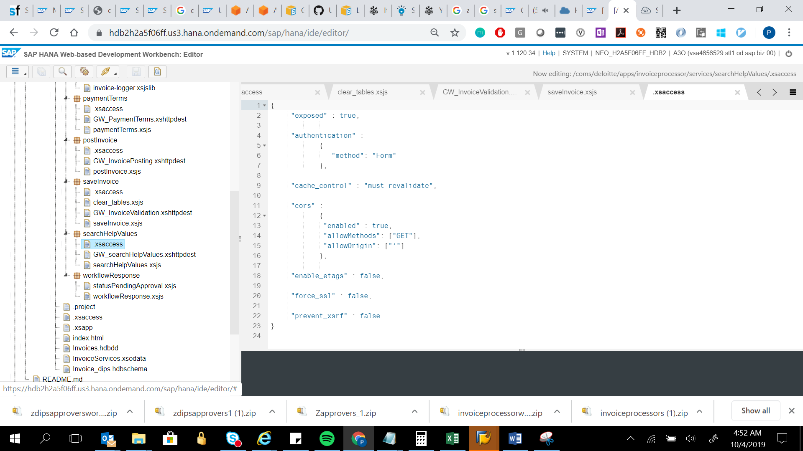

{

"exposed" : true,

"authentication" :

{

"method": "Form"

},

"cache_control" : "must-revalidate",

"cors" :

{

"enabled" : true,

"allowMethods": ["GET"],

"allowOrigin": ["*"]

},

"enable_etags" : false,

"force_ssl" : false,

"prevent_xsrf" : false

}

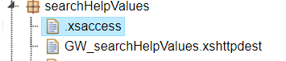

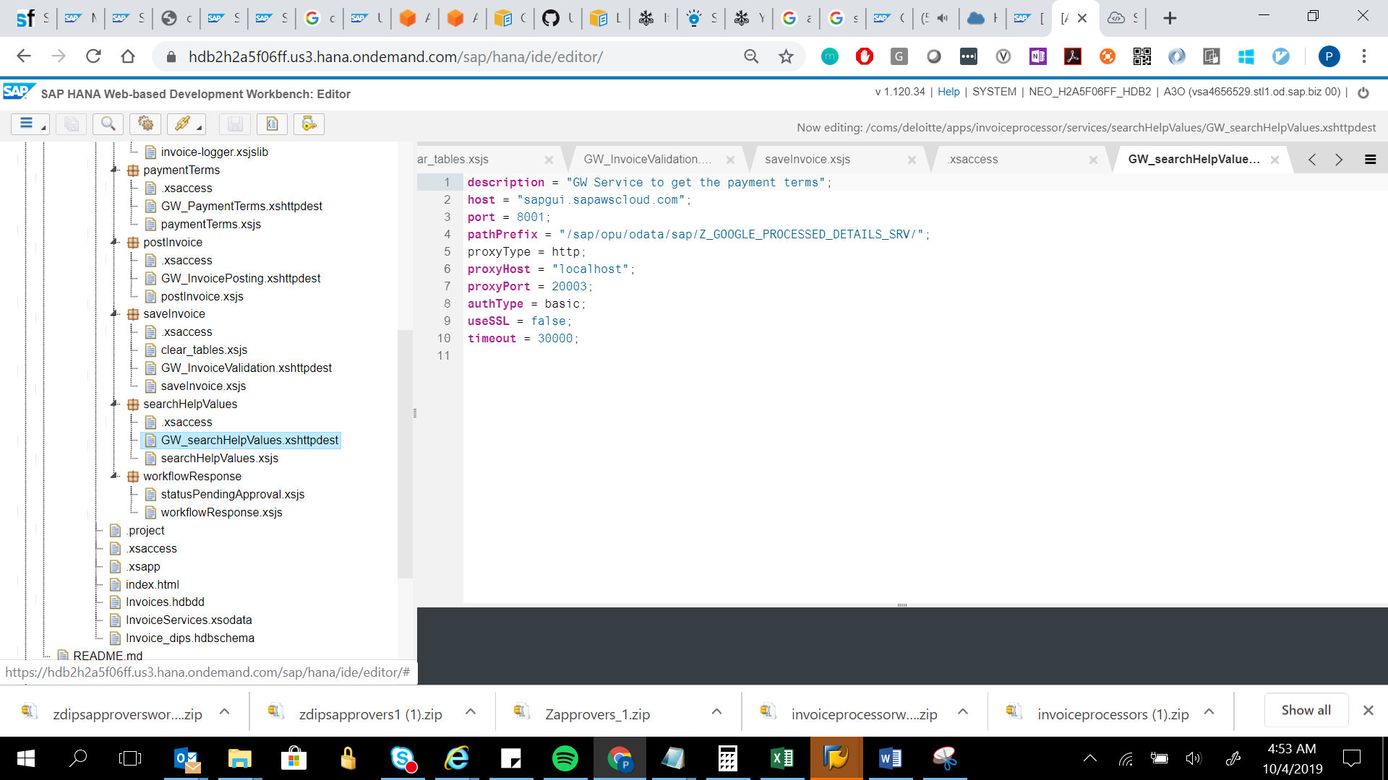

description = "GW Service to get the payment terms";

host = "sapgui.sapawscloud.com";

port = 8001;

pathPrefix = "/sap/opu/odata/sap/Z_GOOGLE_PROCESSED_DETAILS_SRV/";

proxyType = http;

proxyHost = "localhost";

proxyPort = 20003;

authType = basic;

useSSL = false;

timeout = 30000;

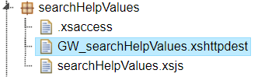

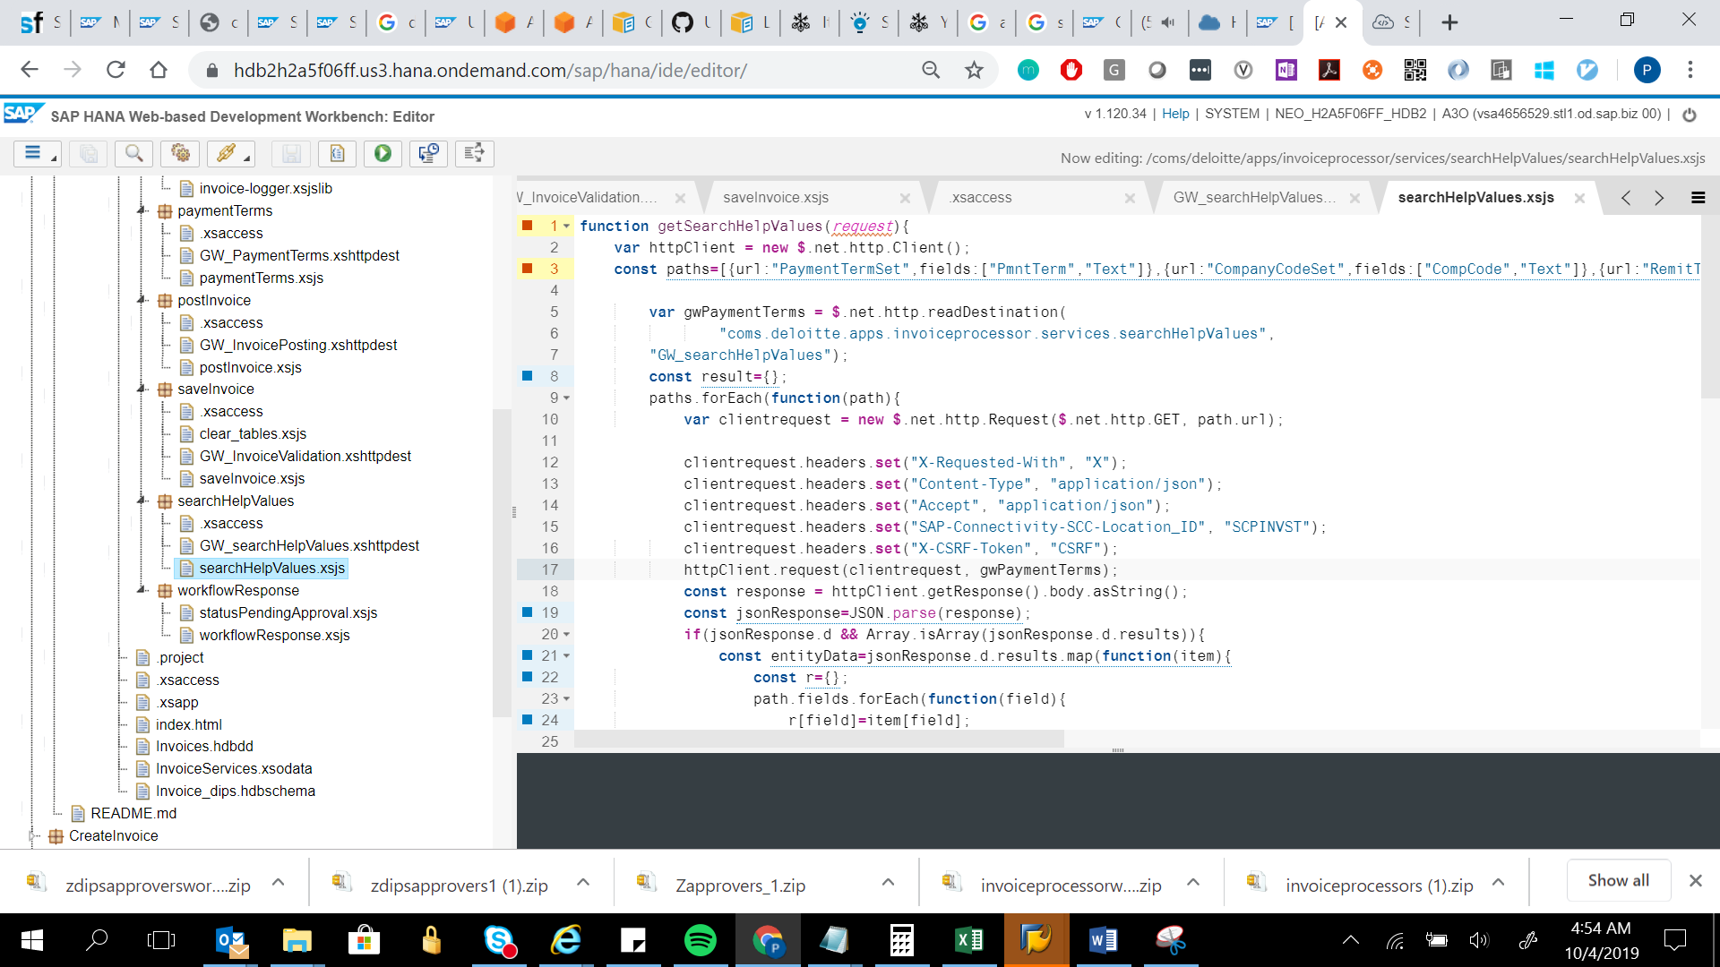

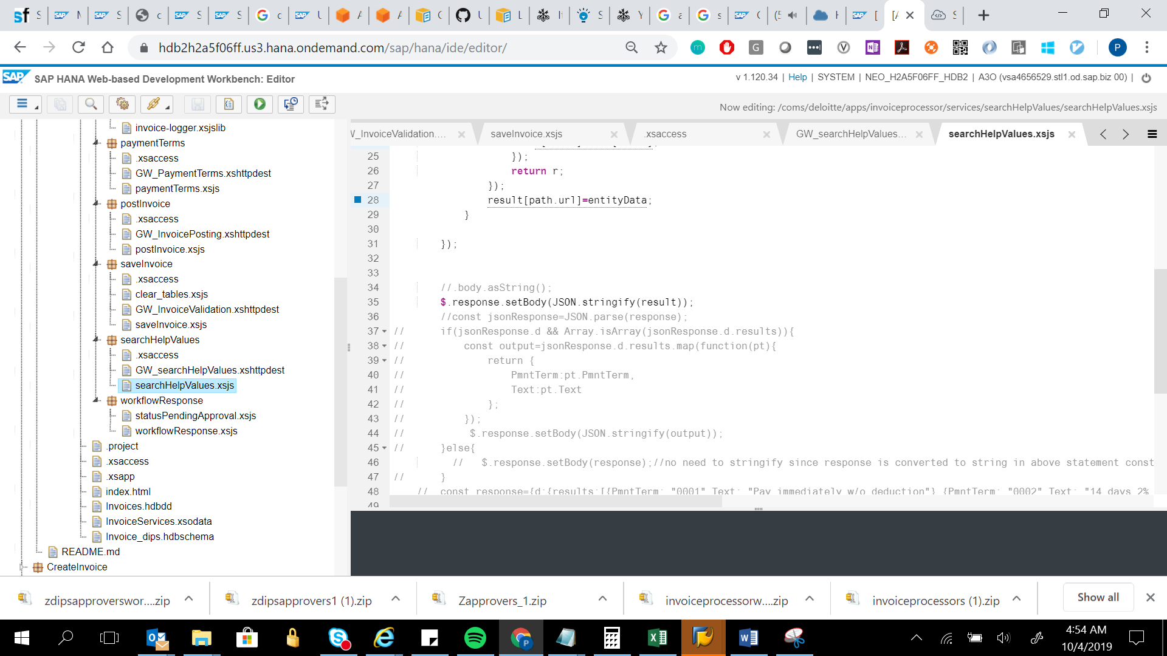

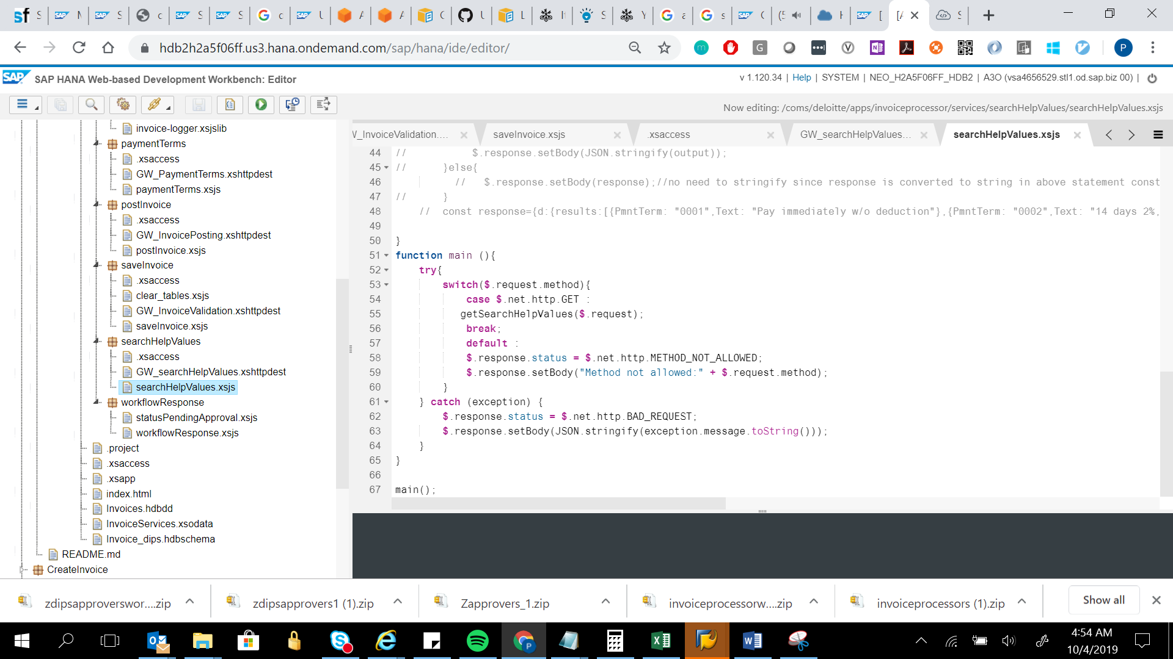

function getSearchHelpValues(request){

var httpClient = new $.net.http.Client();

const paths=[{url:"PaymentTermSet",fields:["PmntTerm","Text"]},{url:"CompanyCodeSet",fields:["CompCode","Text"]},{url:"RemitToSuppIDSet",fields:["RemitToSupID","Name","CompCode"]},{url:"ItemCodeSet",fields:["matnr","maktx","bukrs"]},{url:"UOMSet",fields:["MSEHI","MSEHL","ISOCODE","MSEH3"]}];

var gwPaymentTerms = $.net.http.readDestination(

"coms.deloitte.apps.invoiceprocessor.services.searchHelpValues",

"GW_searchHelpValues");

const result={};

paths.forEach(function(path){

var clientrequest = new $.net.http.Request($.net.http.GET, path.url);

clientrequest.headers.set("X-Requested-With", "X");

clientrequest.headers.set("Content-Type", "application/json");

clientrequest.headers.set("Accept", "application/json");

clientrequest.headers.set("SAP-Connectivity-SCC-Location_ID", "SCPINVST");

clientrequest.headers.set("X-CSRF-Token", "CSRF");

httpClient.request(clientrequest, gwPaymentTerms);

const response = httpClient.getResponse().body.asString();

const jsonResponse=JSON.parse(response);

if(jsonResponse.d && Array.isArray(jsonResponse.d.results)){

const entityData=jsonResponse.d.results.map(function(item){

const r={};

path.fields.forEach(function(field){

r[field]=item[field];

});

return r;

});

result[path.url]=entityData;

}

});

//.body.asString();

$.response.setBody(JSON.stringify(result));

//const jsonResponse=JSON.parse(response);

// if(jsonResponse.d && Array.isArray(jsonResponse.d.results)){

// const output=jsonResponse.d.results.map(function(pt){

// return {

// PmntTerm:pt.PmntTerm,

// Text:pt.Text

// };

// });

// $.response.setBody(JSON.stringify(output));

// }else{

// $.response.setBody(response);//no need to stringify since response is converted to string in above statement const response = httpClient.getResponse().body.asString();

// }

// const response={d:{results:[{PmntTerm: "0001",Text: "Pay immediately w/o deduction"},{PmntTerm: "0002",Text: "14 days 2%, 30 net"}]}};

}

function main (){

try{

switch($.request.method){

case $.net.http.GET :

getSearchHelpValues($.request);

break;

default :

$.response.status = $.net.http.METHOD_NOT_ALLOWED;

$.response.setBody("Method not allowed:" + $.request.method);

}

} catch (exception) {

$.response.status = $.net.http.BAD_REQUEST;

$.response.setBody(JSON.stringify(exception.message.toString()));

}

}

main();



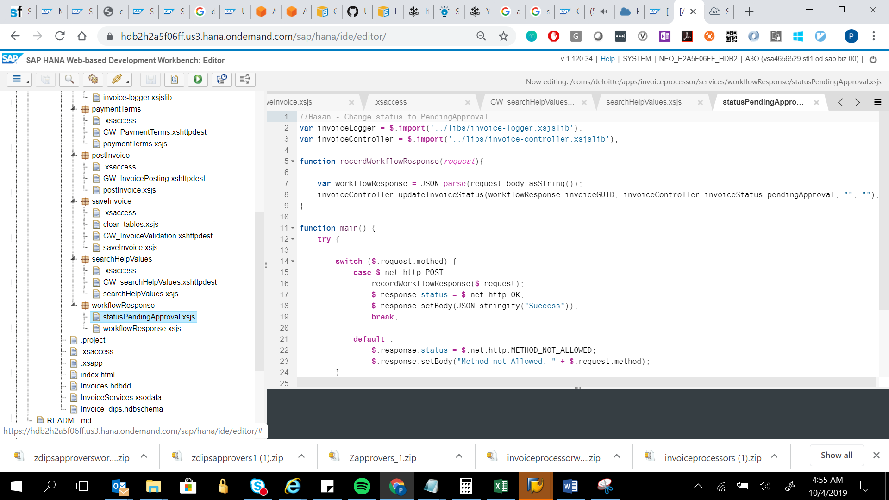

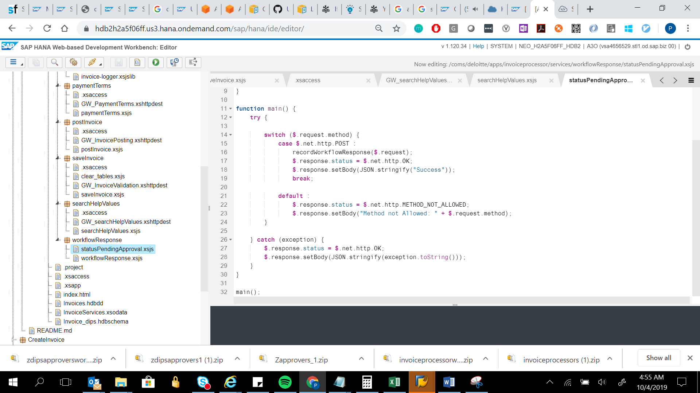

//Hasan - Change status to PendingApproval

var invoiceLogger = $.import('../libs/invoice-logger.xsjslib');

var invoiceController = $.import('../libs/invoice-controller.xsjslib');

function recordWorkflowResponse(request){

var workflowResponse = JSON.parse(request.body.asString());

invoiceController.updateInvoiceStatus(workflowResponse.invoiceGUID, invoiceController.invoiceStatus.pendingApproval, "", "");

}

function main() {

try {

switch ($.request.method) {

case $.net.http.POST :

recordWorkflowResponse($.request);

$.response.status = $.net.http.OK;

$.response.setBody(JSON.stringify("Success"));

break;

default :

$.response.status = $.net.http.METHOD_NOT_ALLOWED;

$.response.setBody("Method not Allowed: " + $.request.method);

}

} catch (exception) {

$.response.status = $.net.http.OK;

$.response.setBody(JSON.stringify(exception.toString()));

}

}

main();

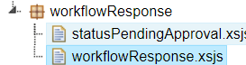

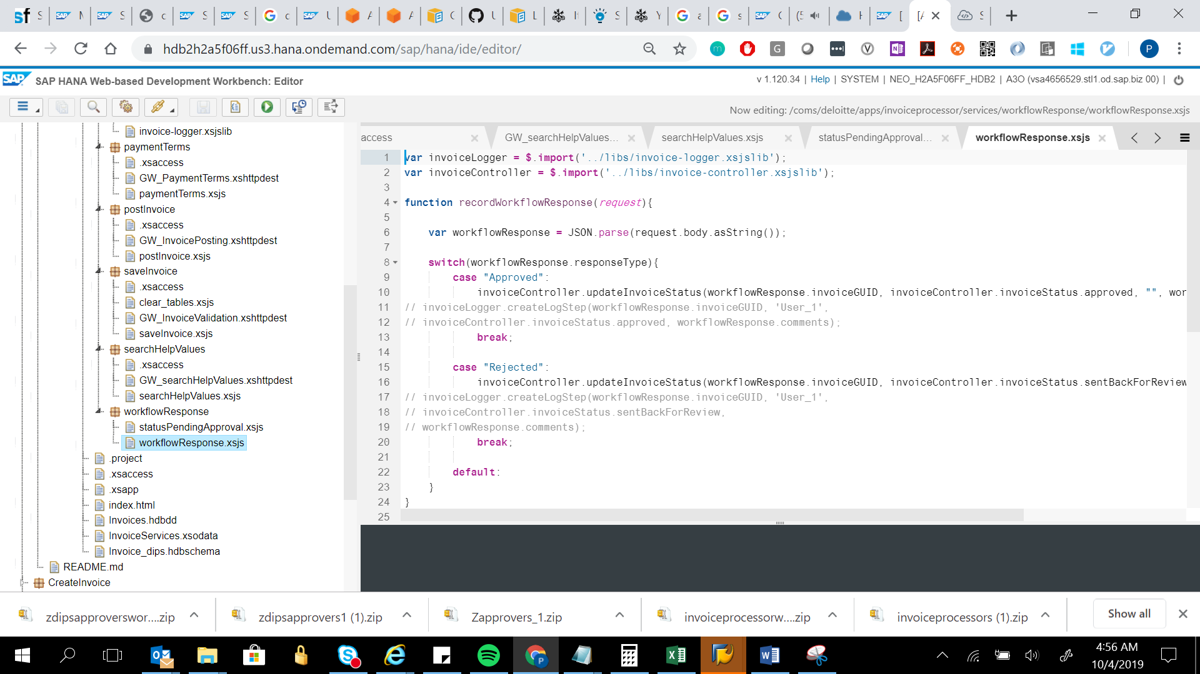

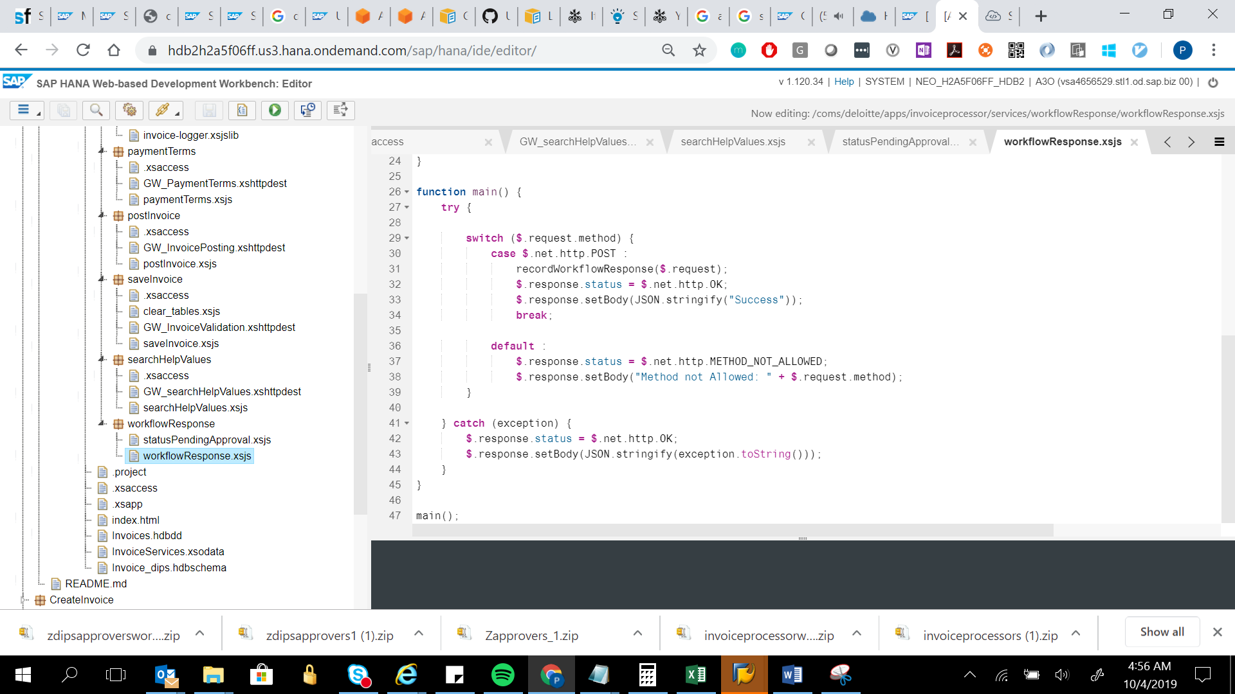

var invoiceLogger = $.import('../libs/invoice-logger.xsjslib');

var invoiceController = $.import('../libs/invoice-controller.xsjslib');

function recordWorkflowResponse(request){

var workflowResponse = JSON.parse(request.body.asString());

switch(workflowResponse.responseType){

case "Approved":

invoiceController.updateInvoiceStatus(workflowResponse.invoiceGUID, invoiceController.invoiceStatus.approved, "", workflowResponse.comments);

// invoiceLogger.createLogStep(workflowResponse.invoiceGUID, 'User_1',

// invoiceController.invoiceStatus.approved, workflowResponse.comments);

break;

case "Rejected":

invoiceController.updateInvoiceStatus(workflowResponse.invoiceGUID, invoiceController.invoiceStatus.sentBackForReview, "", workflowResponse.comments);

// invoiceLogger.createLogStep(workflowResponse.invoiceGUID, 'User_1',

// invoiceController.invoiceStatus.sentBackForReview,

// workflowResponse.comments);

break;

default:

}

}

function main() {

try {

switch ($.request.method) {

case $.net.http.POST :

recordWorkflowResponse($.request);

$.response.status = $.net.http.OK;

$.response.setBody(JSON.stringify("Success"));

break;

default :

$.response.status = $.net.http.METHOD_NOT_ALLOWED;

$.response.setBody("Method not Allowed: " + $.request.method);

}

} catch (exception) {

$.response.status = $.net.http.OK;

$.response.setBody(JSON.stringify(exception.toString()));

}

}

main();



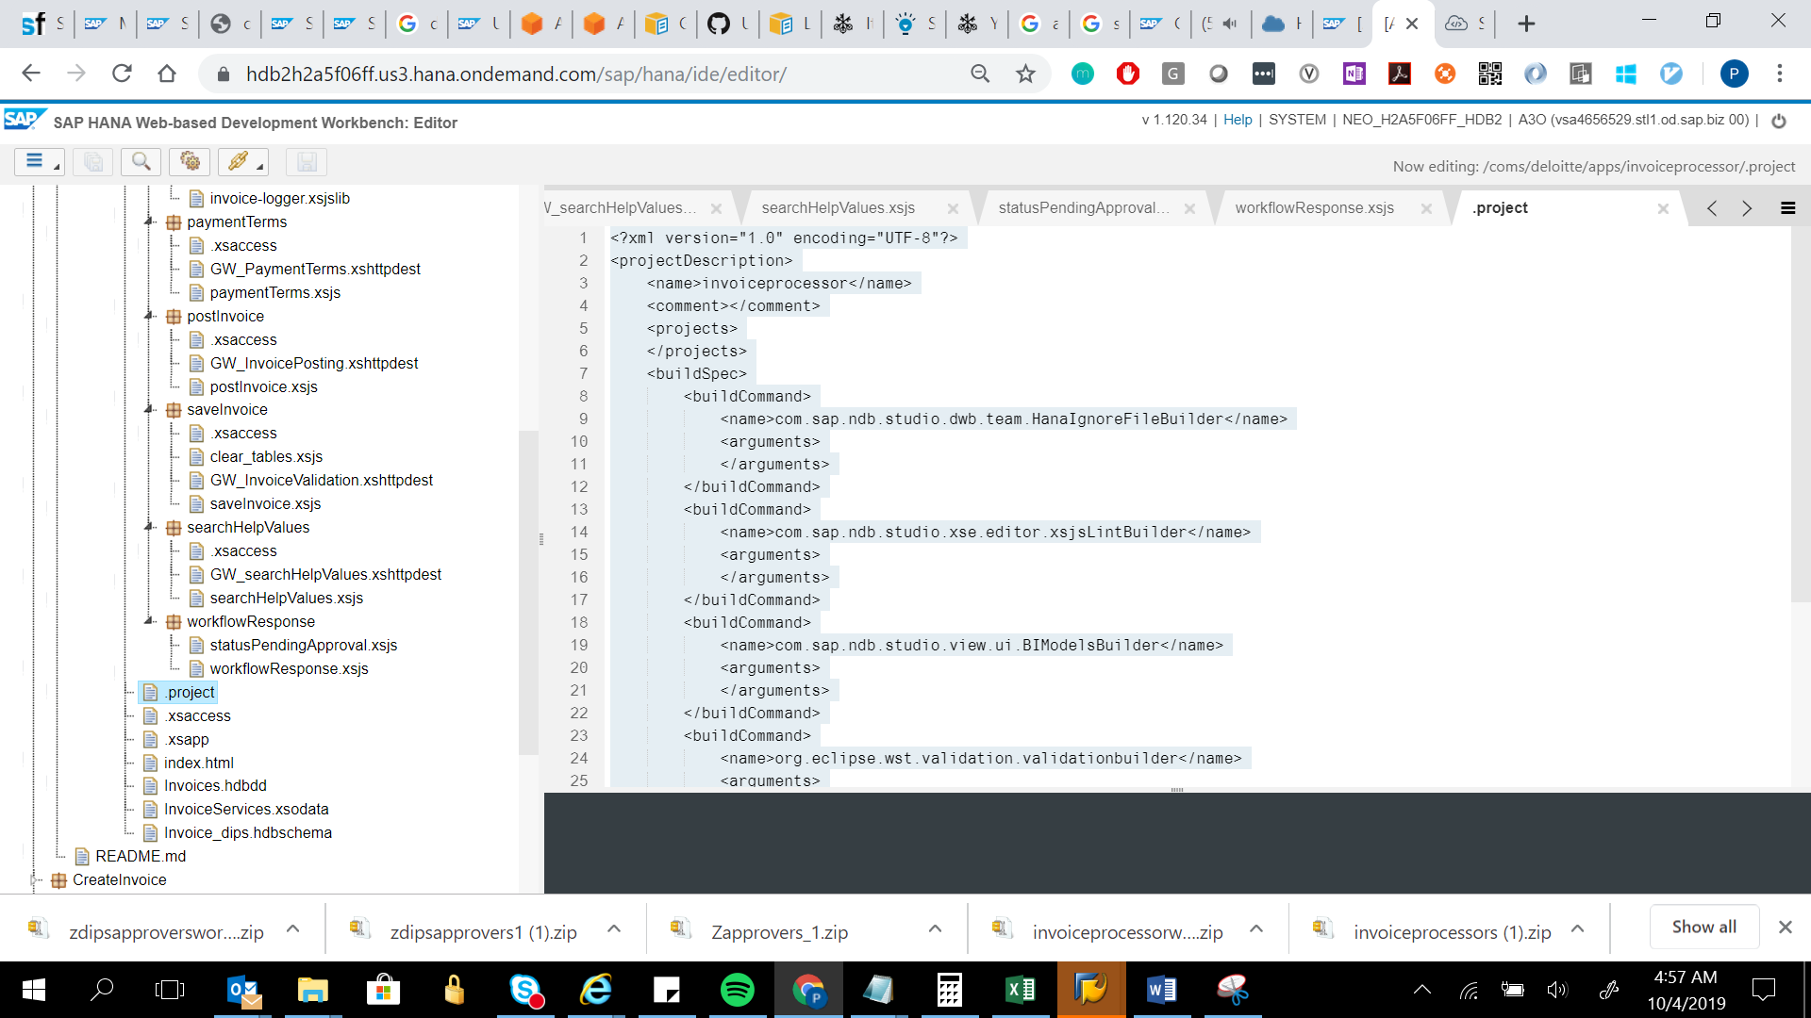

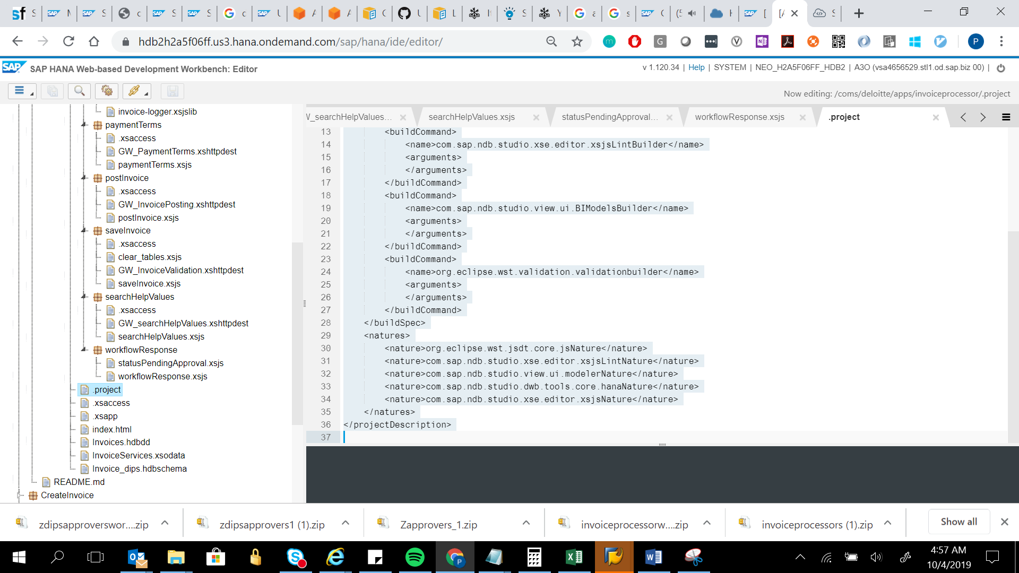

<?xml version="1.0" encoding="UTF-8"?>

<projectDescription>

<name>invoiceprocessor</name>

<comment></comment>

<projects>

</projects>

<buildSpec>

<buildCommand>

<name>com.sap.ndb.studio.dwb.team.HanaIgnoreFileBuilder</name>

<arguments>

</arguments>

</buildCommand>

<buildCommand>

<name>com.sap.ndb.studio.xse.editor.xsjsLintBuilder</name>

<arguments>

</arguments>

</buildCommand>

<buildCommand>

<name>com.sap.ndb.studio.view.ui.BIModelsBuilder</name>

<arguments>

</arguments>

</buildCommand>

<buildCommand>

<name>org.eclipse.wst.validation.validationbuilder</name>

<arguments>

</arguments>

</buildCommand>

</buildSpec>

<natures>

<nature>org.eclipse.wst.jsdt.core.jsNature</nature>

<nature>com.sap.ndb.studio.xse.editor.xsjsLintNature</nature>

<nature>com.sap.ndb.studio.view.ui.modelerNature</nature>

<nature>com.sap.ndb.studio.dwb.tools.core.hanaNature</nature>

<nature>com.sap.ndb.studio.xse.editor.xsjsNature</nature>

</natures>

</projectDescription>

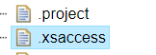

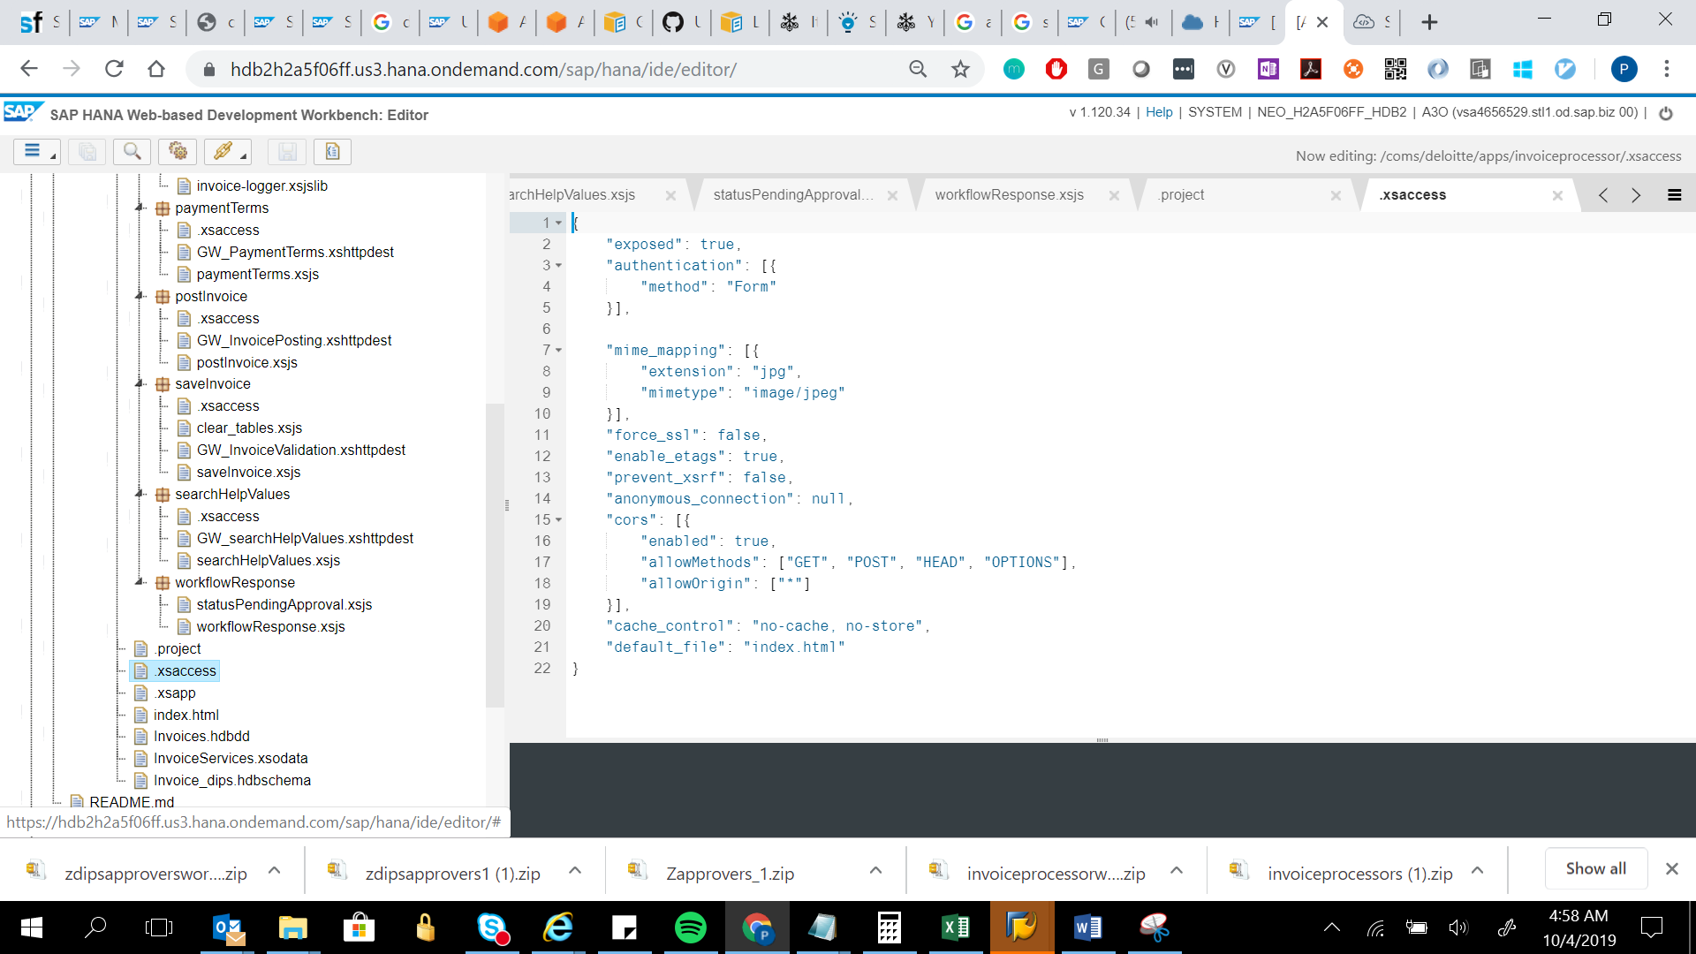

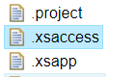

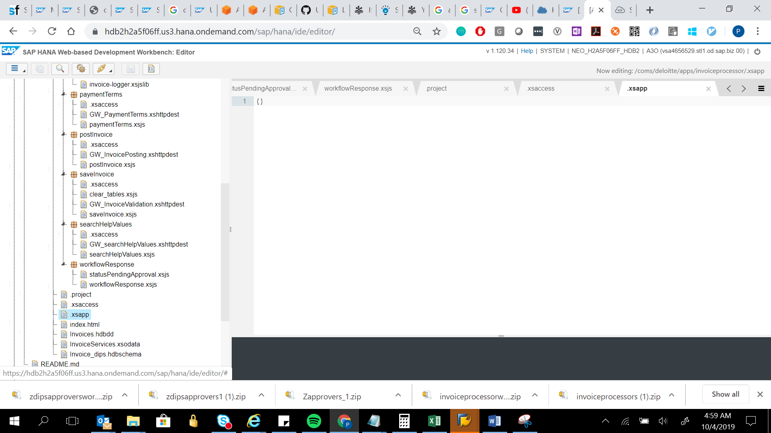

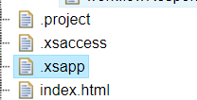

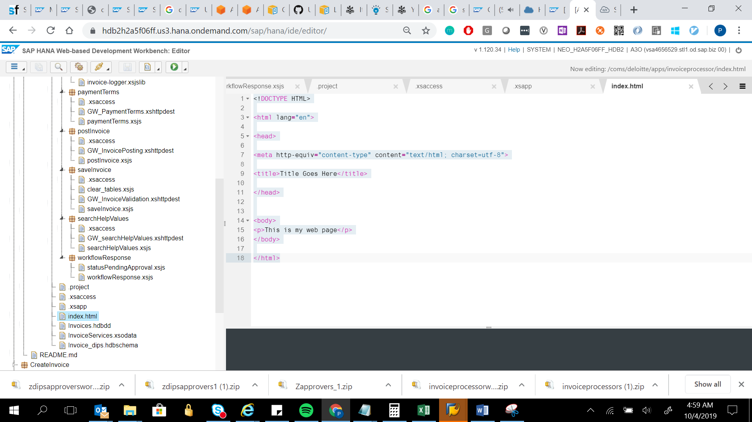

<!DOCTYPE HTML>

<html lang="en">

<head>

<meta http-equiv="content-type" content="text/html; charset=utf-8">

<title>Title Goes Here</title>

</head>

<body>

<p>This is my web page</p>

</body>

</HTML>

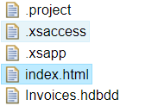

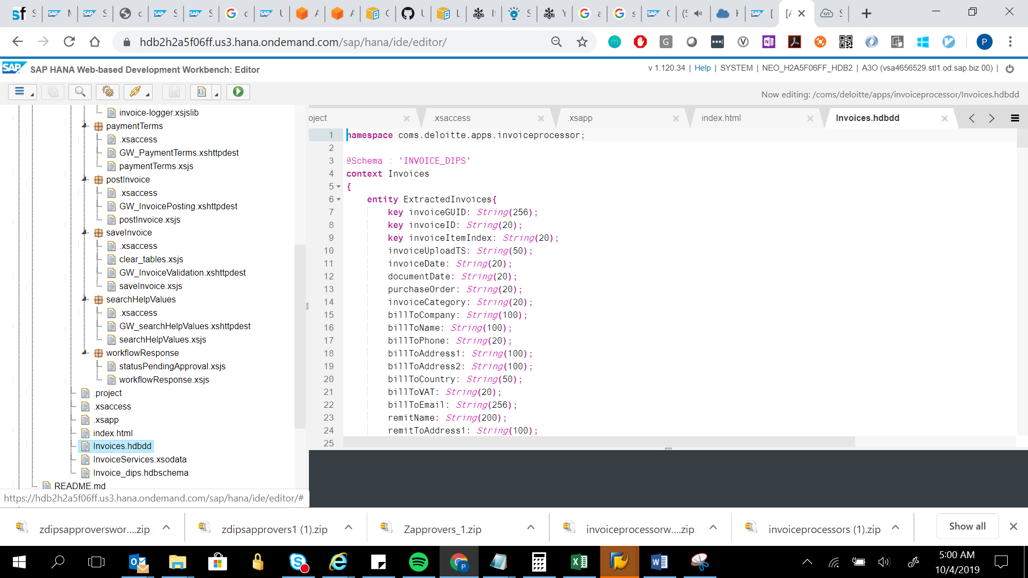

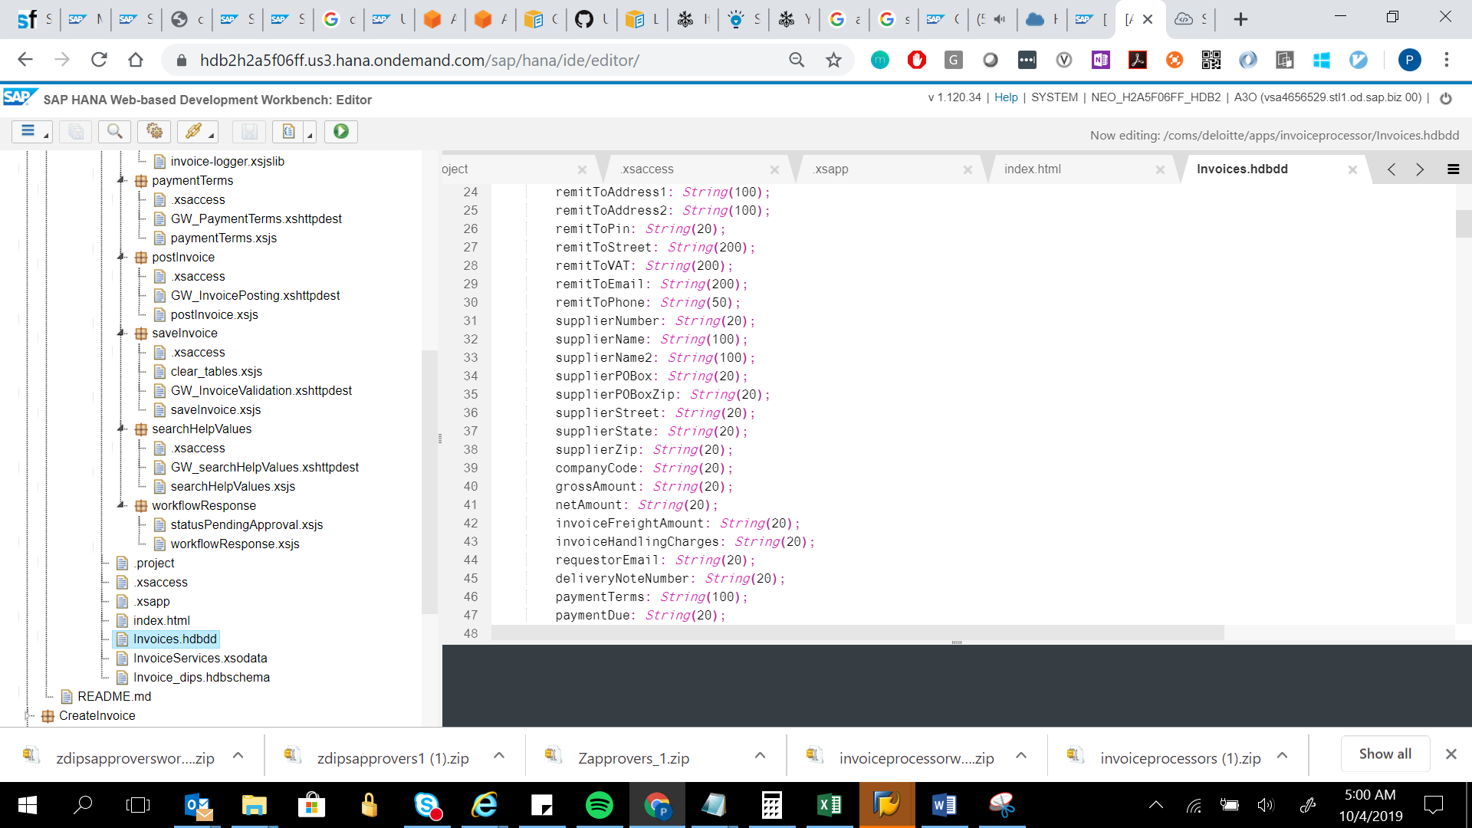

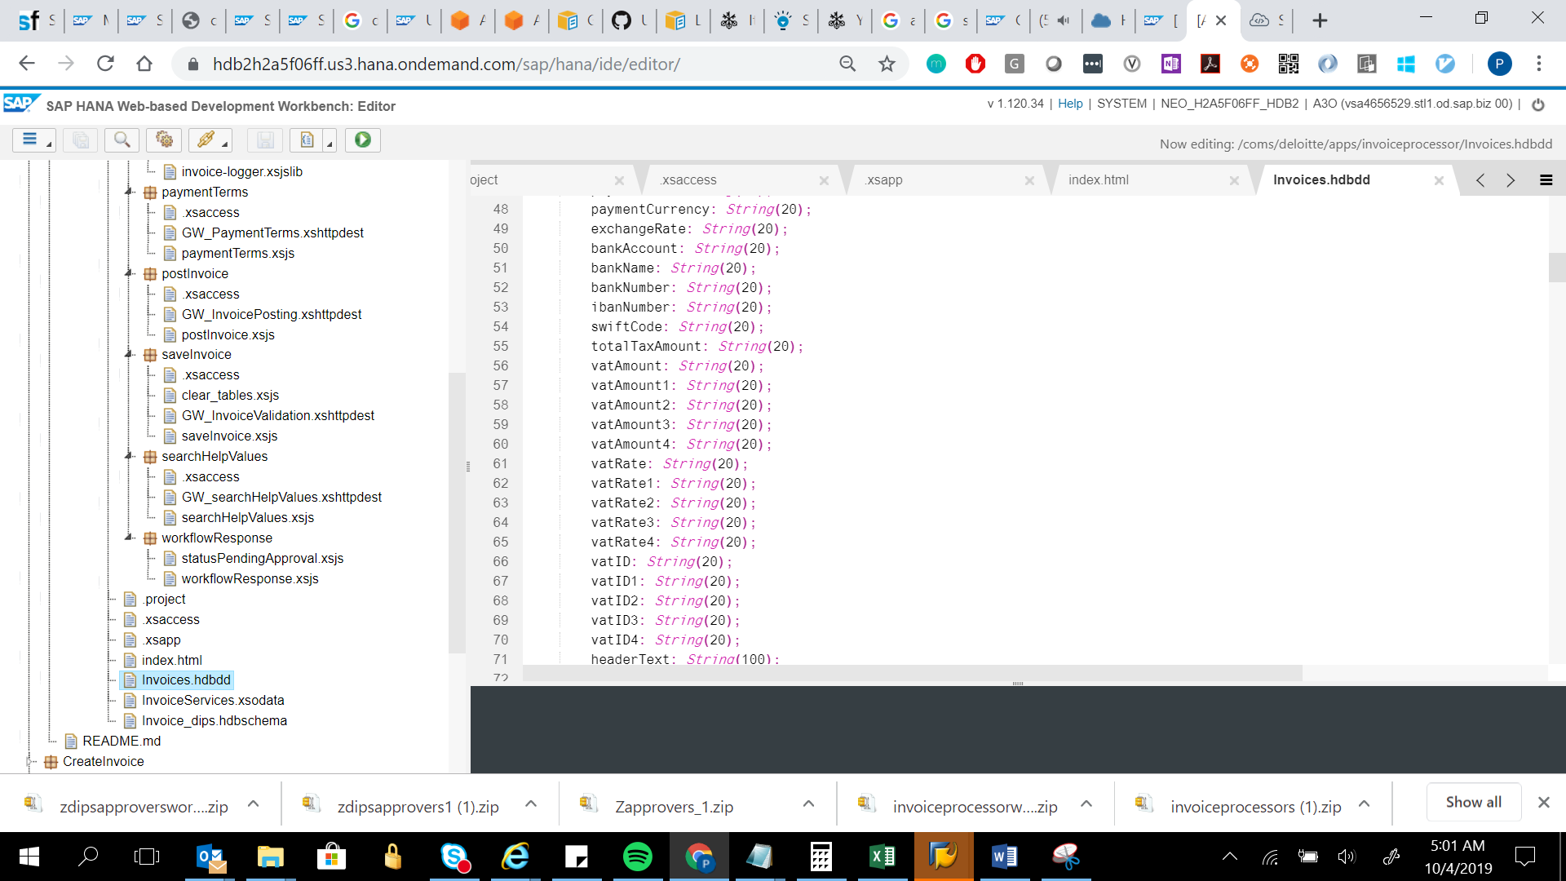

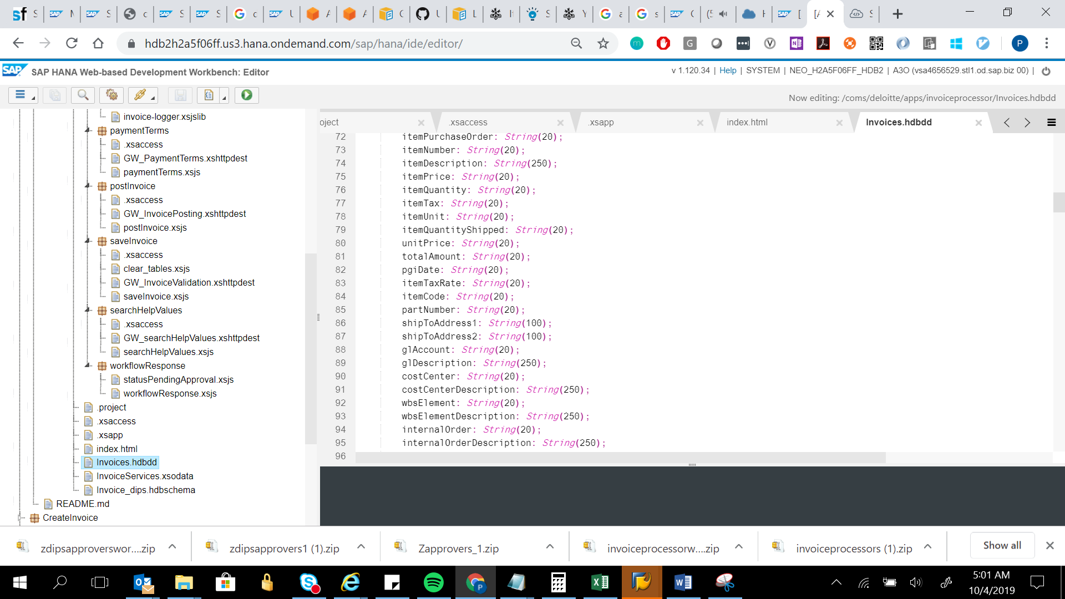

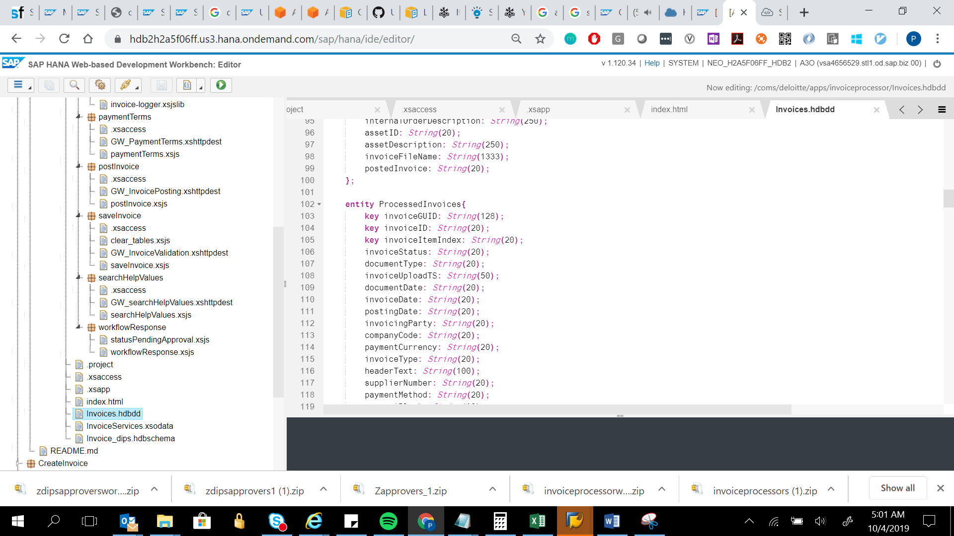

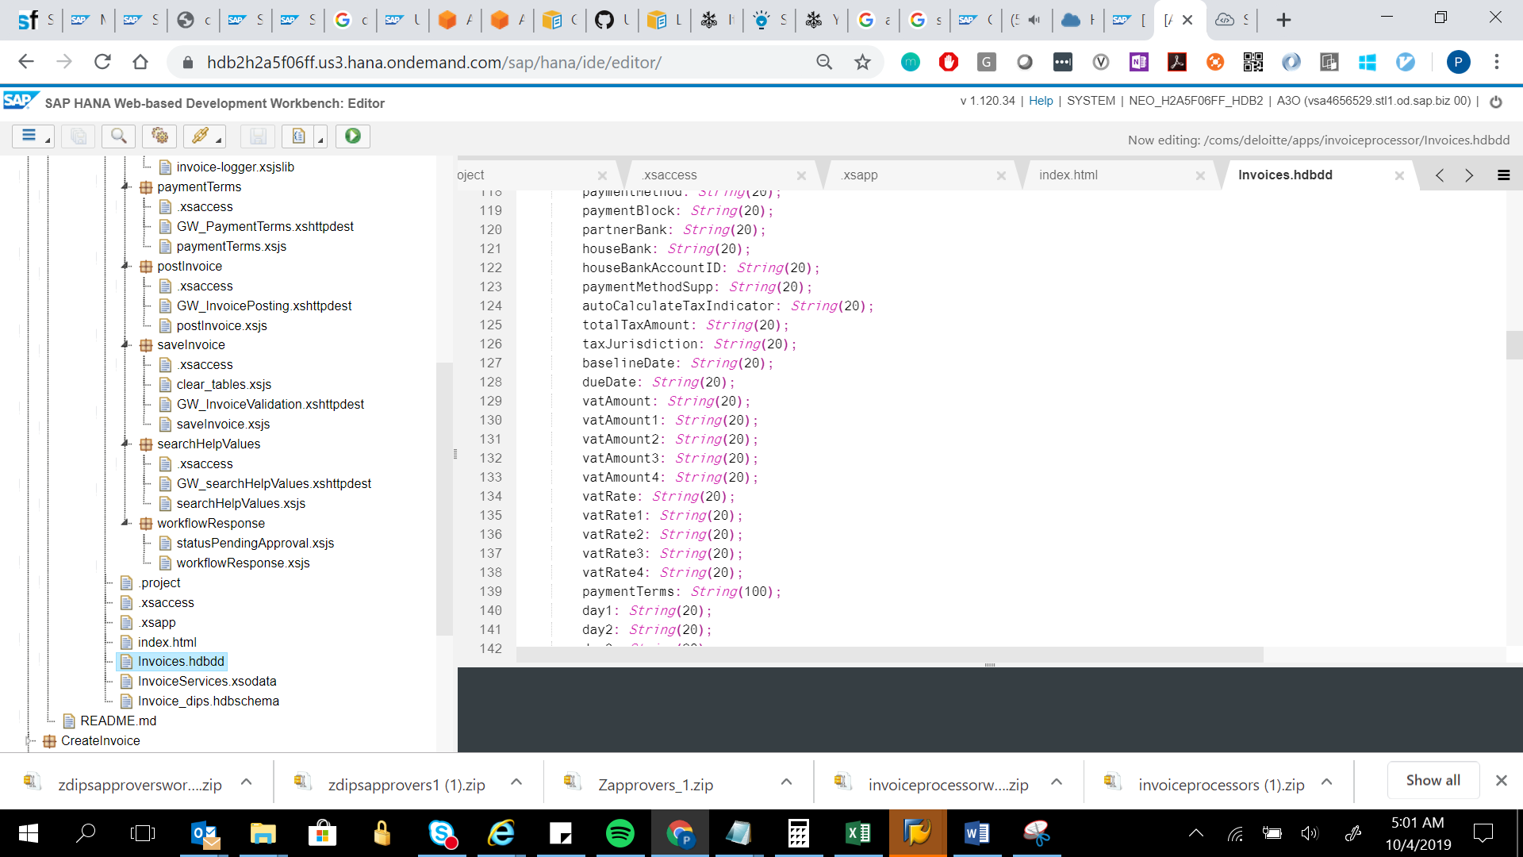

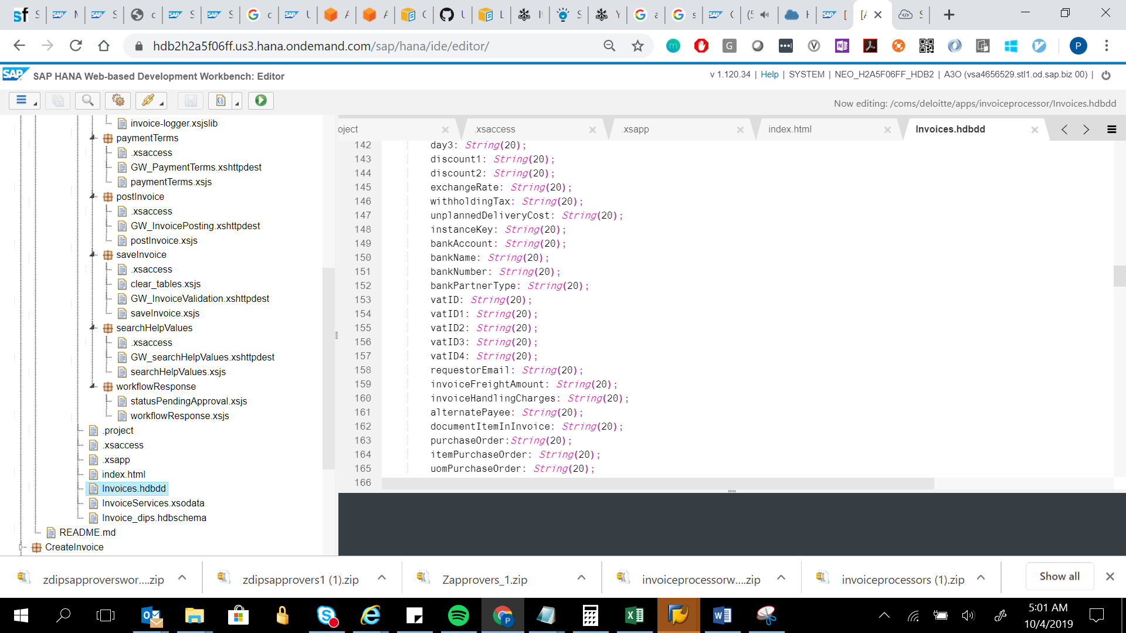

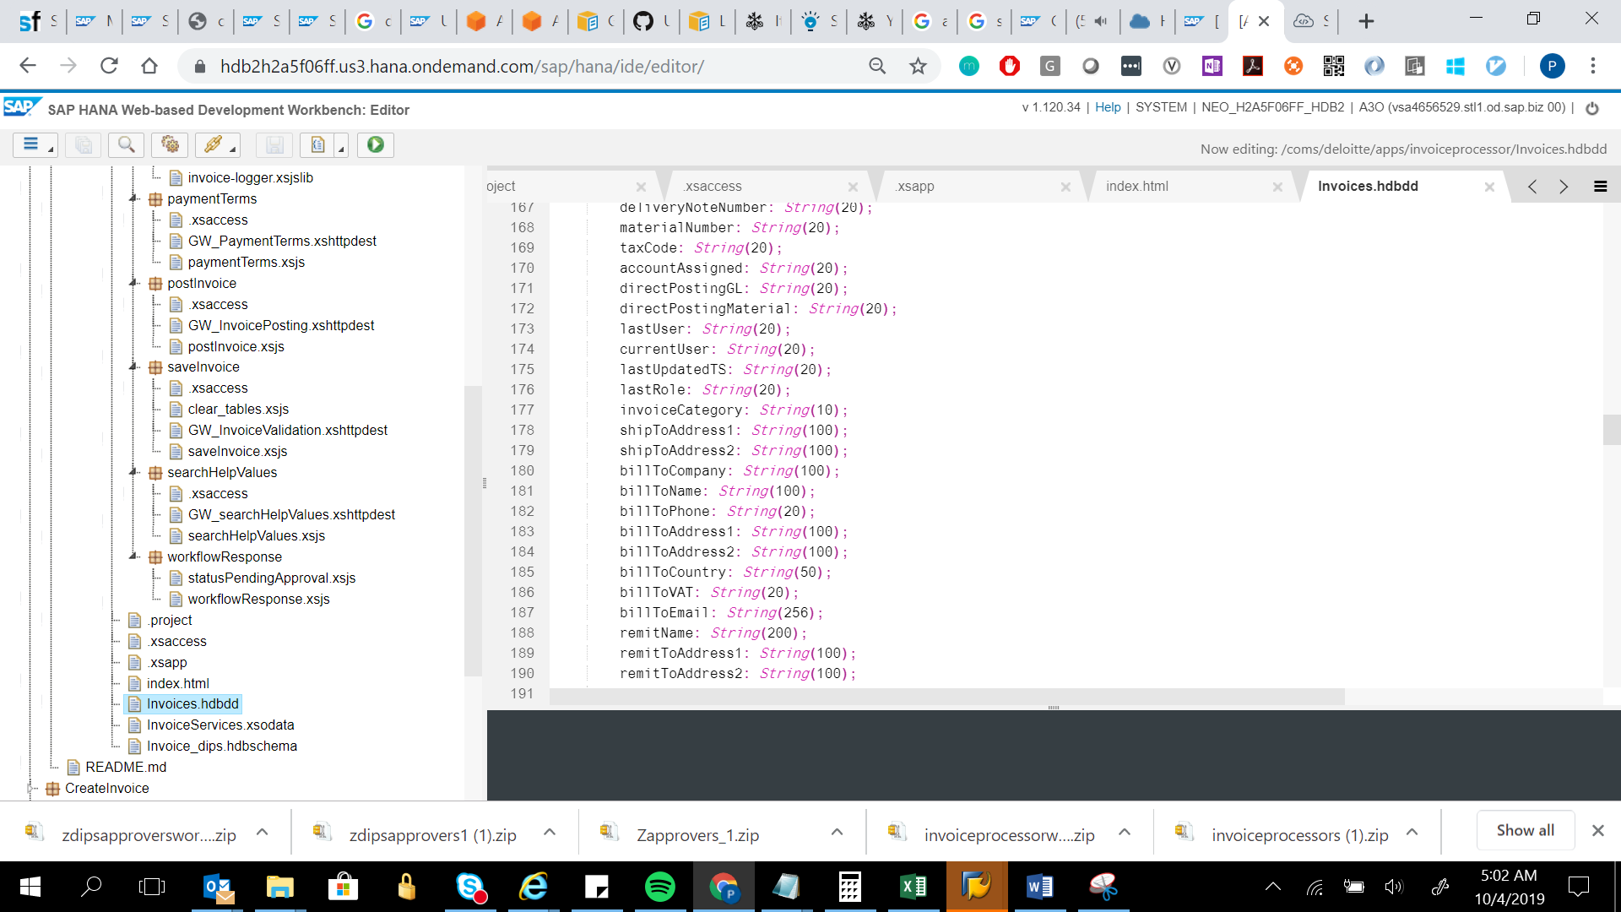

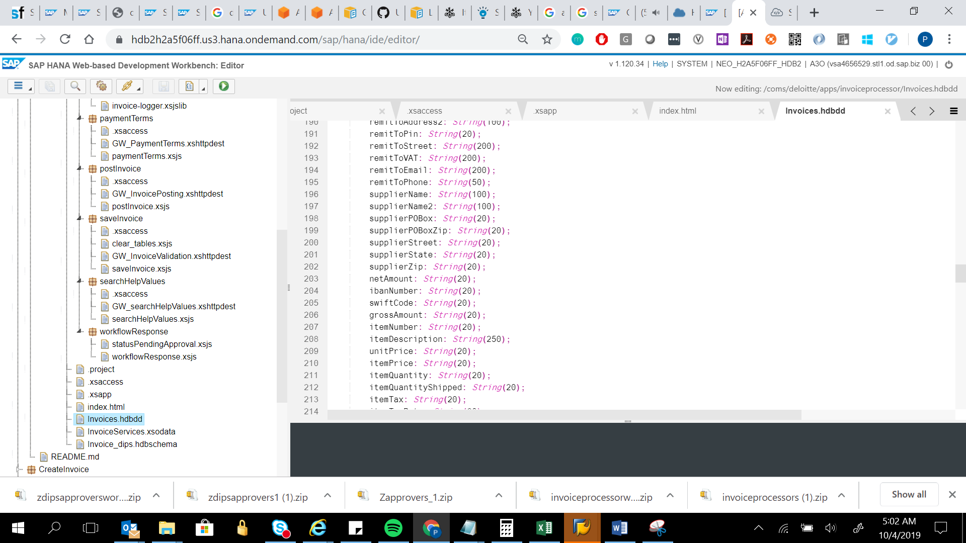

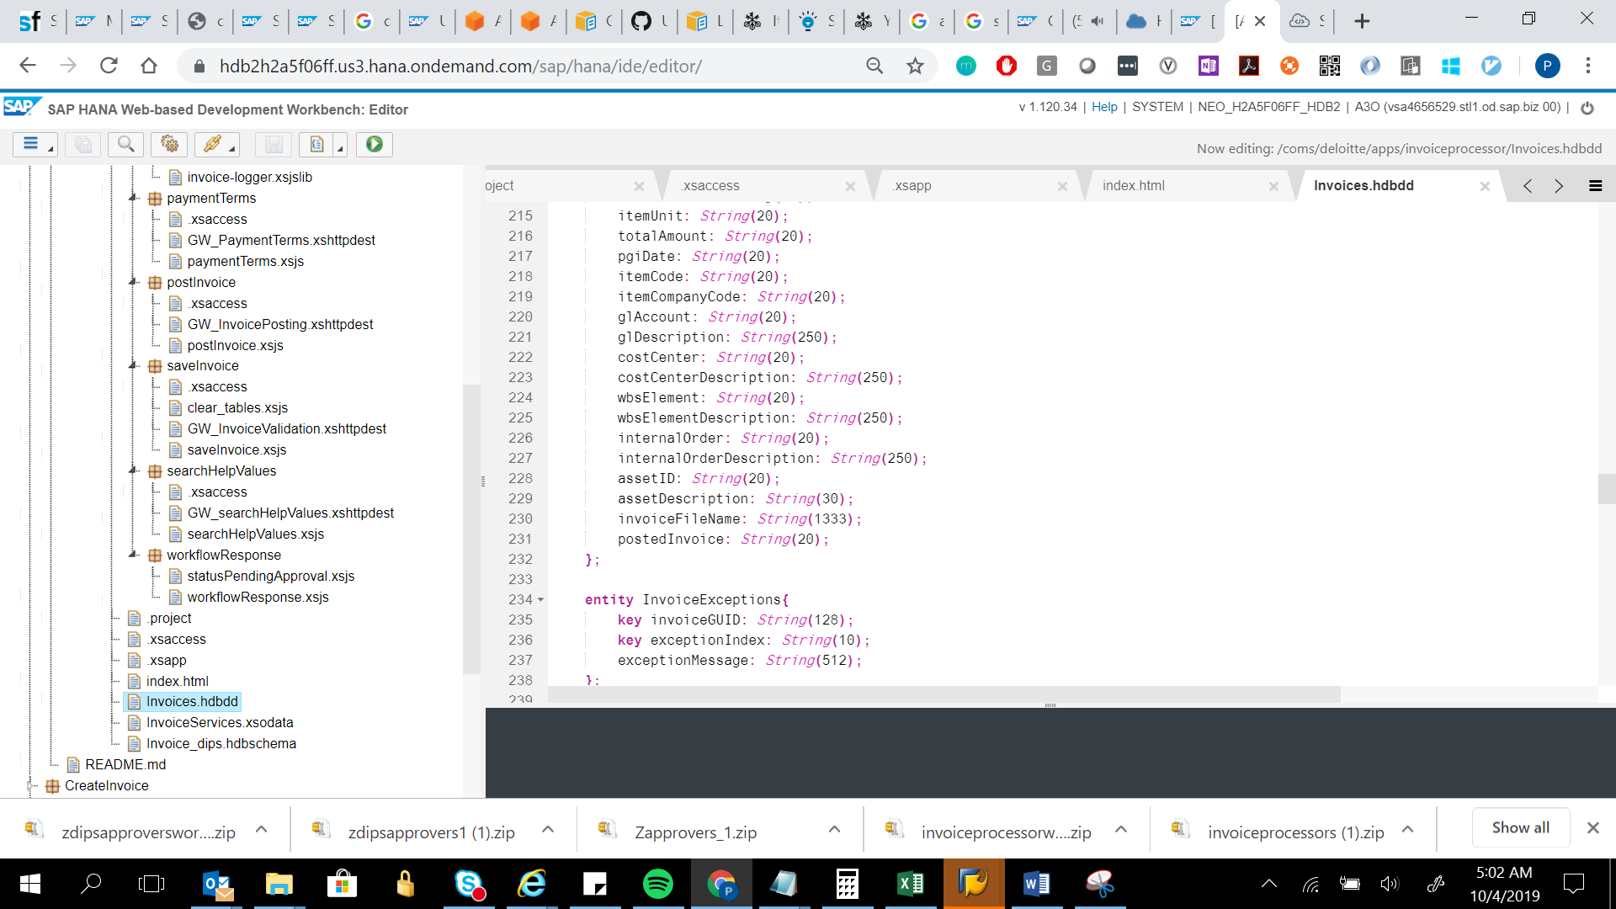

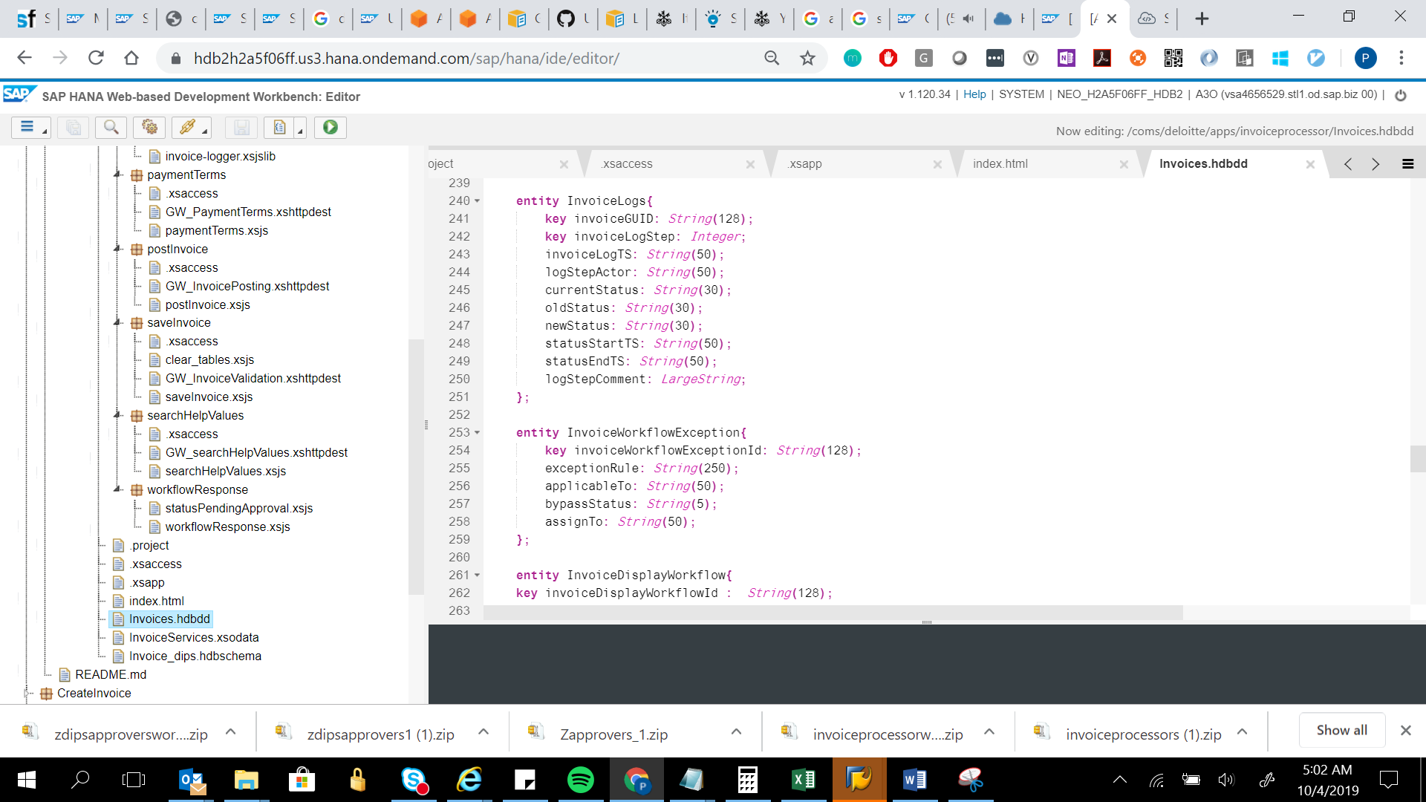

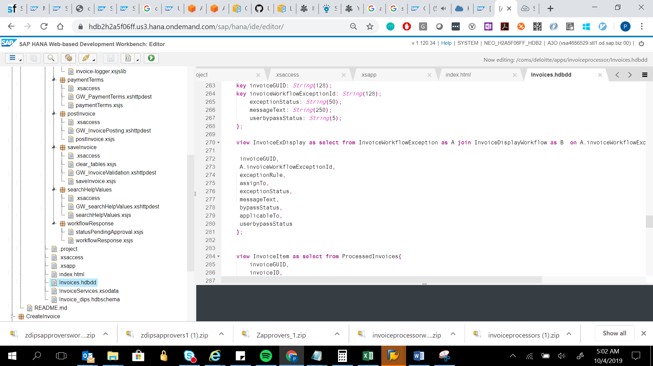

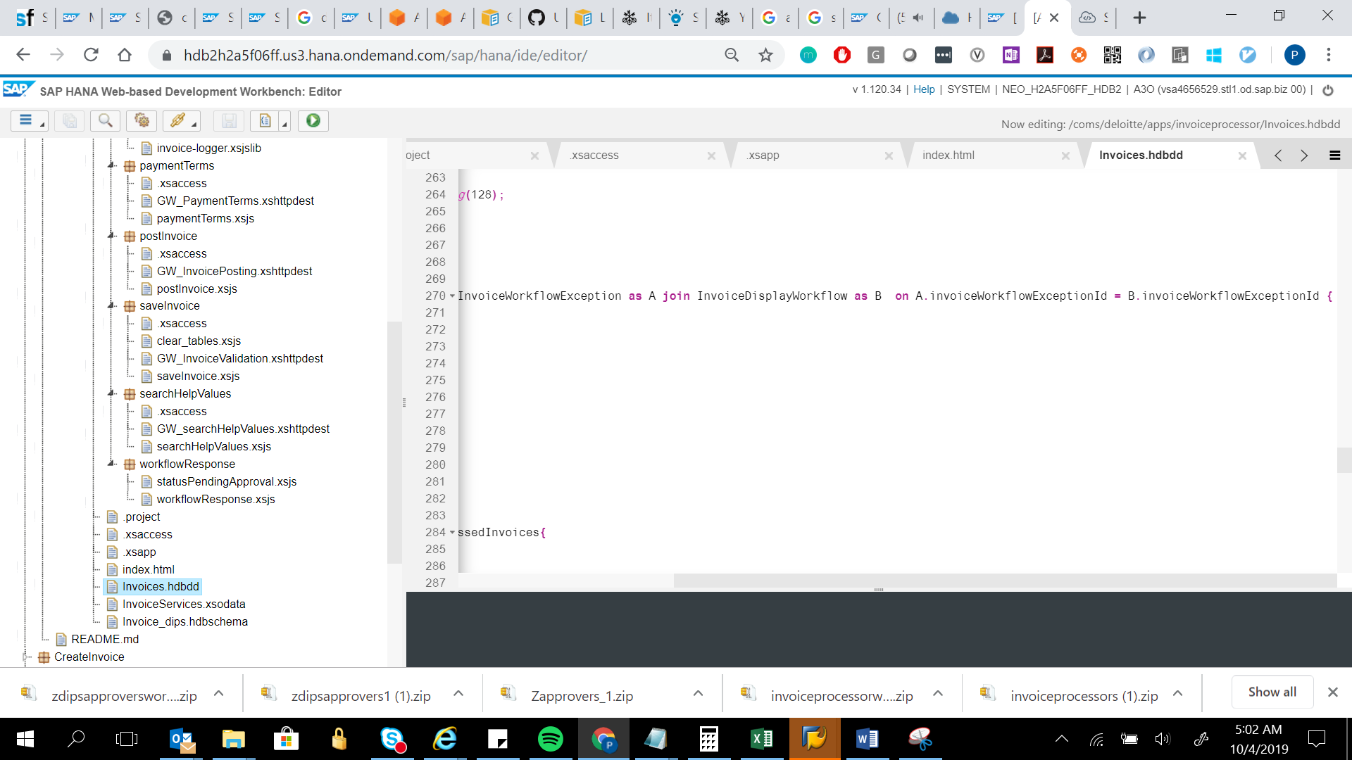

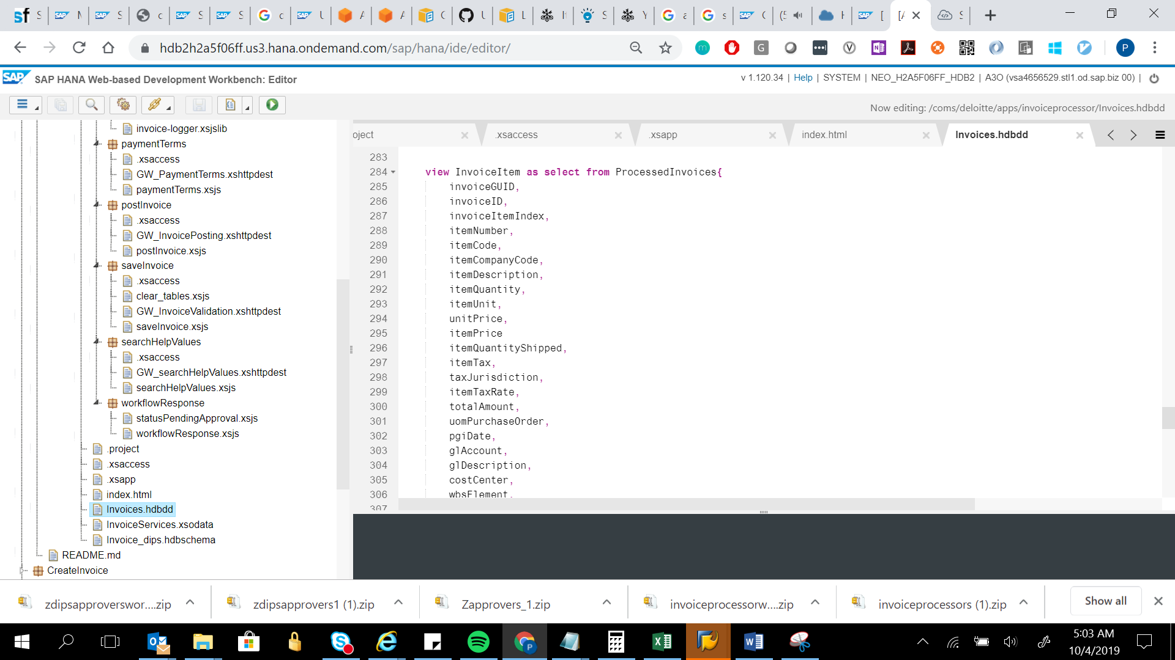

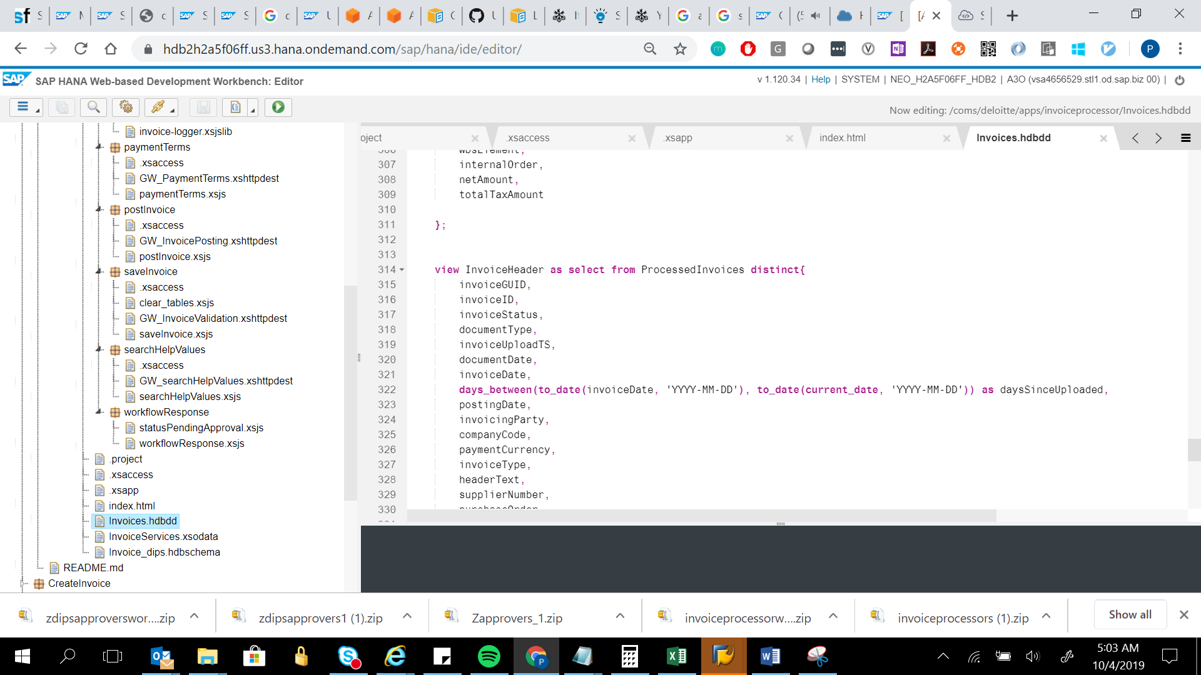

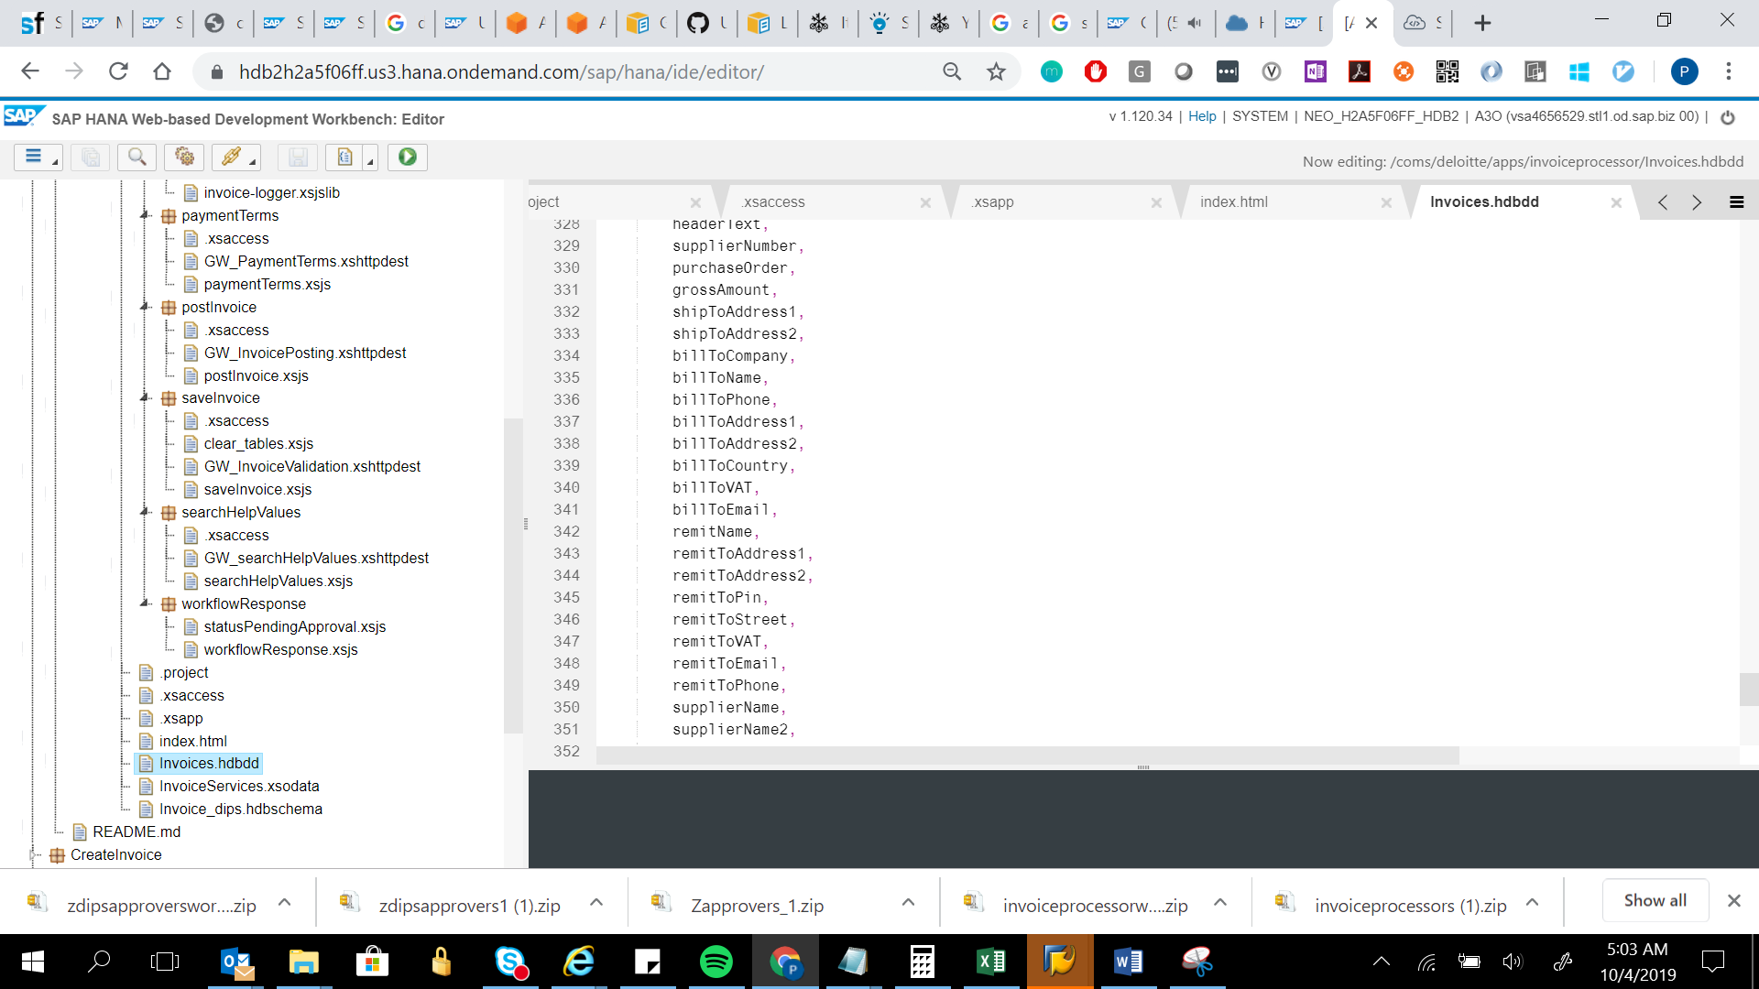

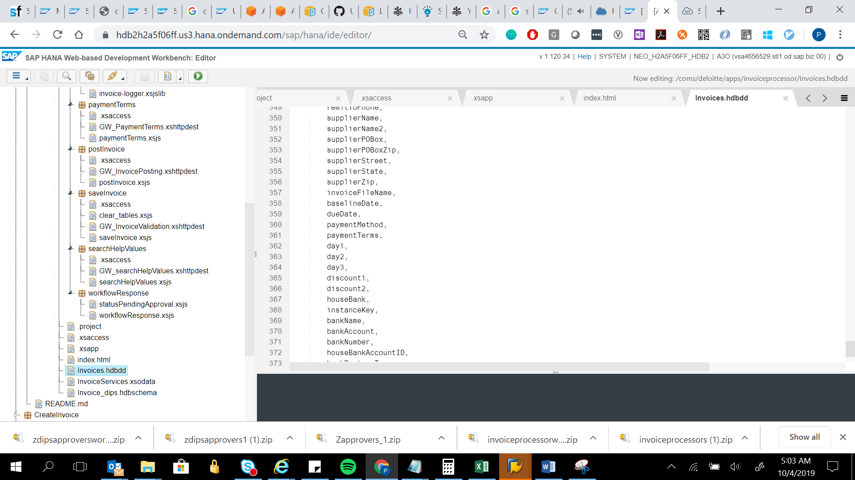

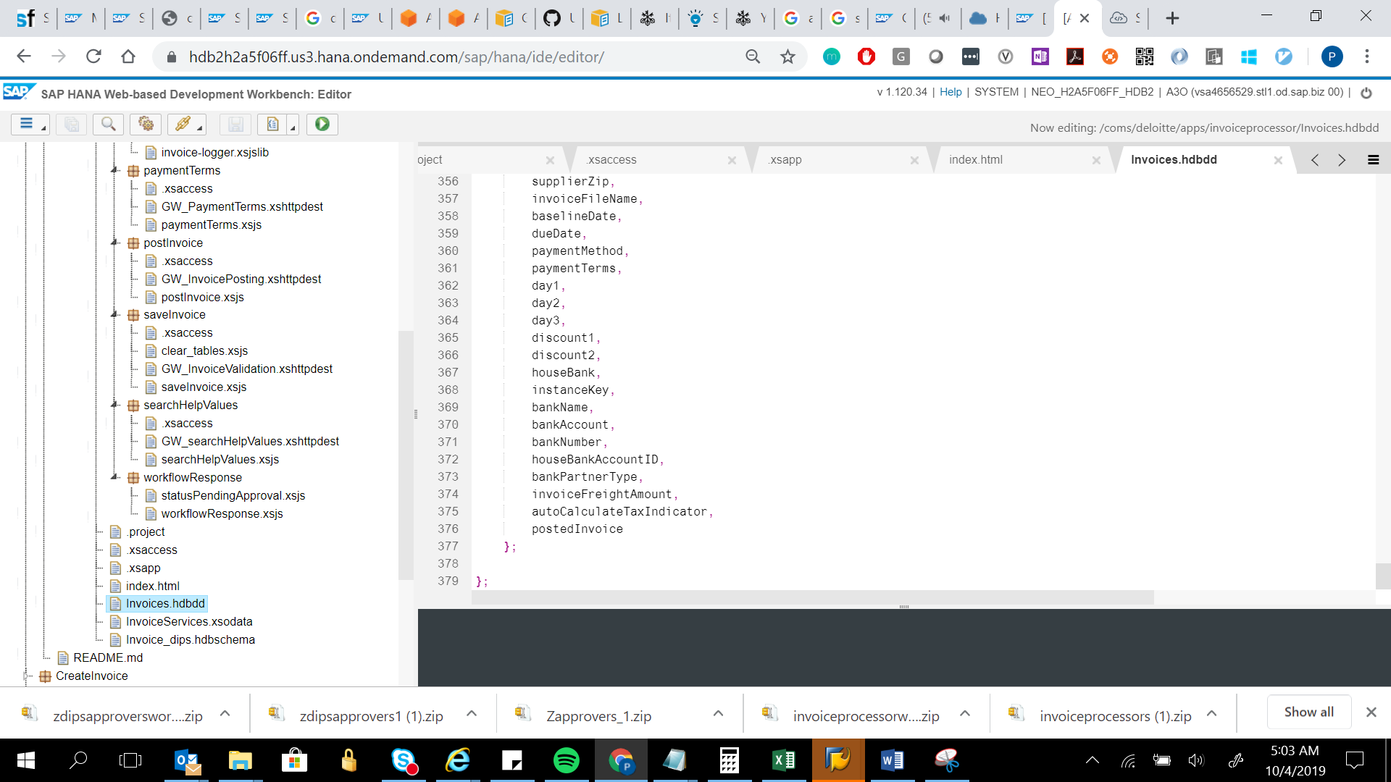

namespace coms.deloitte.apps.invoiceprocessor;

@Schema : 'INVOICE_DIPS'

context Invoices

{

entity ExtractedInvoices{

key invoiceGUID: String(256);

key invoiceID: String(20);

key invoiceItemIndex: String(20);

invoiceUploadTS: String(50);

invoiceDate: String(20);

documentDate: String(20);

purchaseOrder: String(20);

invoiceCategory: String(20);

billToCompany: String(100);

billToName: String(100);

billToPhone: String(20);

billToAddress1: String(100);

billToAddress2: String(100);

billToCountry: String(50);

billToVAT: String(20);

billToEmail: String(256);

remitName: String(200);

remitToAddress1: String(100);

remitToAddress2: String(100);

remitToPin: String(20);

remitToStreet: String(200);

remitToVAT: String(200);

remitToEmail: String(200);

remitToPhone: String(50);

supplierNumber: String(20);

supplierName: String(100);

supplierName2: String(100);

supplierPOBox: String(20);

supplierPOBoxZip: String(20);

supplierStreet: String(20);

supplierState: String(20);

supplierZip: String(20);

companyCode: String(20);

grossAmount: String(20);

netAmount: String(20);

invoiceFreightAmount: String(20);

invoiceHandlingCharges: String(20);

requestorEmail: String(20);

deliveryNoteNumber: String(20);

paymentTerms: String(100);

paymentDue: String(20);

paymentCurrency: String(20);

exchangeRate: String(20);

bankAccount: String(20);

bankName: String(20);

bankNumber: String(20);

ibanNumber: String(20);

swiftCode: String(20);

totalTaxAmount: String(20);

vatAmount: String(20);

vatAmount1: String(20);

vatAmount2: String(20);

vatAmount3: String(20);

vatAmount4: String(20);

vatRate: String(20);

vatRate1: String(20);

vatRate2: String(20);

vatRate3: String(20);

vatRate4: String(20);

vatID: String(20);

vatID1: String(20);

vatID2: String(20);

vatID3: String(20);

vatID4: String(20);

headerText: String(100);

itemPurchaseOrder: String(20);

itemNumber: String(20);

itemDescription: String(250);

itemPrice: String(20);

itemQuantity: String(20);

itemTax: String(20);

itemUnit: String(20);

itemQuantityShipped: String(20);

unitPrice: String(20);

totalAmount: String(20);

pgiDate: String(20);

itemTaxRate: String(20);

itemCode: String(20);

partNumber: String(20);

shipToAddress1: String(100);

shipToAddress2: String(100);

glAccount: String(20);

glDescription: String(250);

costCenter: String(20);

costCenterDescription: String(250);

wbsElement: String(20);

wbsElementDescription: String(250);

internalOrder: String(20);

internalOrderDescription: String(250);

assetID: String(20);

assetDescription: String(250);

invoiceFileName: String(1333);

postedInvoice: String(20);

};

entity ProcessedInvoices{

key invoiceGUID: String(128);

key invoiceID: String(20);

key invoiceItemIndex: String(20);

invoiceStatus: String(20);

documentType: String(20);

invoiceUploadTS: String(50);

documentDate: String(20);

invoiceDate: String(20);

postingDate: String(20);

invoicingParty: String(20);

companyCode: String(20);

paymentCurrency: String(20);

invoiceType: String(20);

headerText: String(100);

supplierNumber: String(20);

paymentMethod: String(20);

paymentBlock: String(20);

partnerBank: String(20);

houseBank: String(20);

houseBankAccountID: String(20);

paymentMethodSupp: String(20);

autoCalculateTaxIndicator: String(20);

totalTaxAmount: String(20);

taxJurisdiction: String(20);

baselineDate: String(20);

dueDate: String(20);

vatAmount: String(20);

vatAmount1: String(20);

vatAmount2: String(20);

vatAmount3: String(20);

vatAmount4: String(20);

vatRate: String(20);

vatRate1: String(20);

vatRate2: String(20);

vatRate3: String(20);

vatRate4: String(20);

paymentTerms: String(100);

day1: String(20);

day2: String(20);

day3: String(20);

discount1: String(20);

discount2: String(20);

exchangeRate: String(20);

withholdingTax: String(20);

unplannedDeliveryCost: String(20);

instanceKey: String(20);

bankAccount: String(20);

bankName: String(20);

bankNumber: String(20);

bankPartnerType: String(20);

vatID: String(20);

vatID1: String(20);

vatID2: String(20);

vatID3: String(20);

vatID4: String(20);

requestorEmail: String(20);

invoiceFreightAmount: String(20);

invoiceHandlingCharges: String(20);

alternatePayee: String(20);

documentItemInInvoice: String(20);

purchaseOrder:String(20);

itemPurchaseOrder: String(20);

uomPurchaseOrder: String(20);

amountDocumentCurrency: String(20);

deliveryNoteNumber: String(20);

materialNumber: String(20);

taxCode: String(20);

accountAssigned: String(20);

directPostingGL: String(20);

directPostingMaterial: String(20);

lastUser: String(20);

currentUser: String(20);

lastUpdatedTS: String(20);

lastRole: String(20);

invoiceCategory: String(10);

shipToAddress1: String(100);

shipToAddress2: String(100);

billToCompany: String(100);

billToName: String(100);

billToPhone: String(20);

billToAddress1: String(100);

billToAddress2: String(100);

billToCountry: String(50);

billToVAT: String(20);

billToEmail: String(256);

remitName: String(200);

remitToAddress1: String(100);

remitToAddress2: String(100);

remitToPin: String(20);

remitToStreet: String(200);

remitToVAT: String(200);

remitToEmail: String(200);

remitToPhone: String(50);

supplierName: String(100);

supplierName2: String(100);

supplierPOBox: String(20);

supplierPOBoxZip: String(20);

supplierStreet: String(20);

supplierState: String(20);

supplierZip: String(20);

netAmount: String(20);

ibanNumber: String(20);

swiftCode: String(20);

grossAmount: String(20);

itemNumber: String(20);

itemDescription: String(250);

unitPrice: String(20);

itemPrice: String(20);

itemQuantity: String(20);

itemQuantityShipped: String(20);

itemTax: String(20);

itemTaxRate: String(20);

itemUnit: String(20);

totalAmount: String(20);

pgiDate: String(20);

itemCode: String(20);

itemCompanyCode: String(20);

glAccount: String(20);

glDescription: String(250);

costCenter: String(20);

costCenterDescription: String(250);

wbsElement: String(20);

wbsElementDescription: String(250);

internalOrder: String(20);

internalOrderDescription: String(250);

assetID: String(20);

assetDescription: String(30);

invoiceFileName: String(1333);

postedInvoice: String(20);

};

entity InvoiceExceptions{

key invoiceGUID: String(128);

key exceptionIndex: String(10);

exceptionMessage: String(512);

};

entity InvoiceLogs{

key invoiceGUID: String(128);

key invoiceLogStep: Integer;

invoiceLogTS: String(50);

logStepActor: String(50);

currentStatus: String(30);

oldStatus: String(30);

newStatus: String(30);

statusStartTS: String(50);

statusEndTS: String(50);

logStepComment: LargeString;

};

entity InvoiceWorkflowException{

key invoiceWorkflowExceptionId: String(128);

exceptionRule: String(250);

applicableTo: String(50);

bypassStatus: String(5);

assignTo: String(50);

};

entity InvoiceDisplayWorkflow{

key invoiceDisplayWorkflowId : String(128);

key invoiceGUID: String(128);

key invoiceWorkflowExceptionId: String(128);

exceptionStatus: String(50);

messageText: String(250);

userbypassStatus: String(5);

};

view InvoiceExDisplay as select from InvoiceWorkflowException as A join InvoiceDisplayWorkflow as B on A.invoiceWorkflowExceptionId = B.invoiceWorkflowExceptionId {

invoiceGUID,

A.invoiceWorkflowExceptionId,

exceptionRule,

assignTo,

exceptionStatus,

messageText,

bypassStatus,

applicableTo,

userbypassStatus

};

view InvoiceItem as select from ProcessedInvoices{

invoiceGUID,

invoiceID,

invoiceItemIndex,

itemNumber,

itemCode,

itemCompanyCode,

itemDescription,

itemQuantity,

itemUnit,

unitPrice,

itemPrice

itemQuantityShipped,

itemTax,

taxJurisdiction,

itemTaxRate,

totalAmount,

uomPurchaseOrder,

pgiDate,

glAccount,

glDescription,

costCenter,

wbsElement,

internalOrder,

netAmount,

totalTaxAmount

};

view InvoiceHeader as select from ProcessedInvoices distinct{

invoiceGUID,

invoiceID,

invoiceStatus,

documentType,

invoiceUploadTS,

documentDate,

invoiceDate,

days_between(to_date(invoiceDate, 'YYYY-MM-DD'), to_date(current_date, 'YYYY-MM-DD')) as daysSinceUploaded,

postingDate,

invoicingParty,

companyCode,

paymentCurrency,

invoiceType,

headerText,

supplierNumber,

purchaseOrder,

grossAmount,

shipToAddress1,

shipToAddress2,

billToCompany,

billToName,

billToPhone,

billToAddress1,

billToAddress2,

billToCountry,

billToVAT,

billToEmail,

remitName,

remitToAddress1,

remitToAddress2,

remitToPin,

remitToStreet,

remitToVAT,

remitToEmail,

remitToPhone,

supplierName,

supplierName2,

supplierPOBox,

supplierPOBoxZip,

supplierStreet,

supplierState,

supplierZip,

invoiceFileName,

baselineDate,

dueDate,

paymentMethod,

paymentTerms,

day1,

day2,

day3,

discount1,

discount2,

houseBank,

instanceKey,

bankName,

bankAccount,

bankNumber,

houseBankAccountID,

bankPartnerType,

invoiceFreightAmount,

autoCalculateTaxIndicator,

postedInvoice

};

};

